RFate

***Modelling vegetation spatially and temporally,  
through plant functional groups***

**Version 1.0**

**User Manual**

*Laboratoire d’Ecologie Alpine, UGA, CNRS, Grenoble, France,*

February 2021

**TABLE OF CONTENTS**

1. **Introduction**
2. **Plant Functional Groups**
   1. Principle
   2. Building PFG
      1. Selection of dominant species
      2. Overlap of species environmental niches
      3. Species pairwise distance
      4. Clustering
3. **Modelling framework**
   1. Parameter files
   2. Core module (succession)
      1. Conceptual diagram
      2. Life cycle of each PFG and influences from sub-models
      3. Calculation of pixel resources
      4. Structural equations
   3. Optional modules
      1. Dispersal
      2. Habitat suitability
      3. Light interaction
      4. Soil interaction
      5. Disturbances
      6. Drought
      7. Aliens
      8. Fire
4. **Run a FATE simulation**
5. **Outputs & analyses**
   1. FATE outputs
   2. Temporal evolution
   3. From abundance to presence/absence
   4. Visualization of outputs

**Publications**

**Supplementary material**

1. **Introduction**
2. **Plant Functional Groups**
   1. **Principle**

« The recurring suggestions are that models should explicitly (i) include spatiotemporal dynamics; (ii) consider multiple species in interactions and (iii) account for the processes shaping biodiversity distribution. » FATE is a « a biodiversity model that meets this challenge at regional scale by combining phenomenological and process-based approaches and using well-defined **plant functional group**. » (Boulangeat, 2014)

A plant functional group, or **PFG**, is « *a set of representative species [that] is classified based on key biological characteristics, to determine groups of species sharing ecological strategies.* » (Boulangeat, 2012)

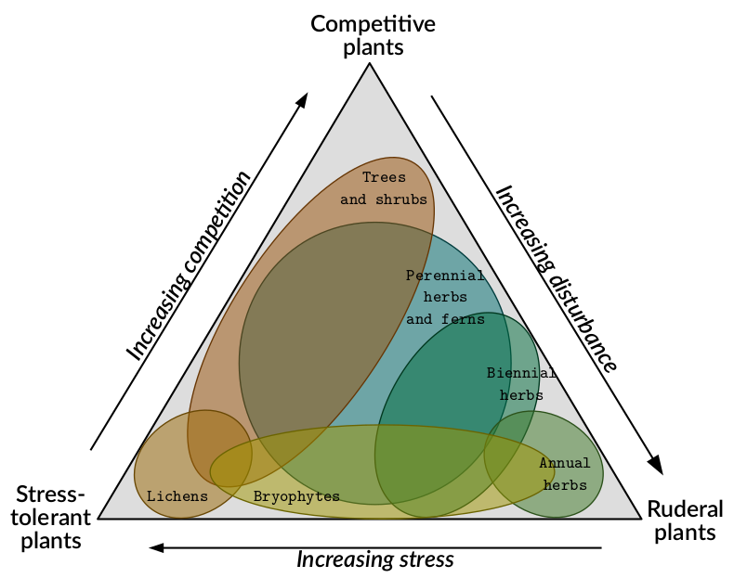

Figure : C-S-R triangle theory

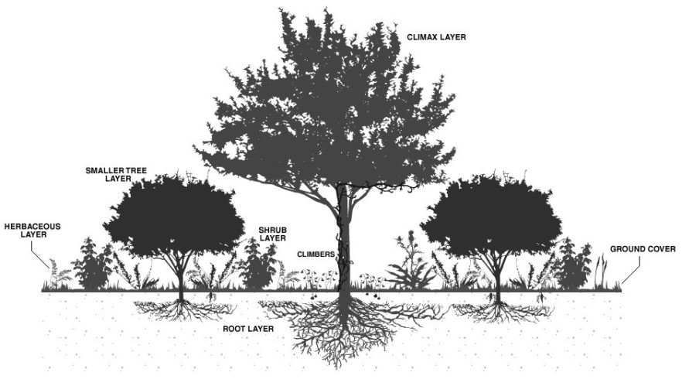

Figure : Vegetation layers

« ***Dominant species*** *are usually seen as the main drivers of vegetation dynamics and ecosystem functioning (‘Biomass ratio hypothesis’ (Grime, 1998),* Fig1*). Moreover, according to the well-known species-abundance distribution (Whittaker, 1965), just a few species produce most of the community’s biomass.* ***In each vegetation strata (herbaceous, shrub, trees)*** (Fig2)*, these species are the most important, not only for structuring the landscape, but also explaining patterns of functional diversity.* » (Boulangeat, 2012)

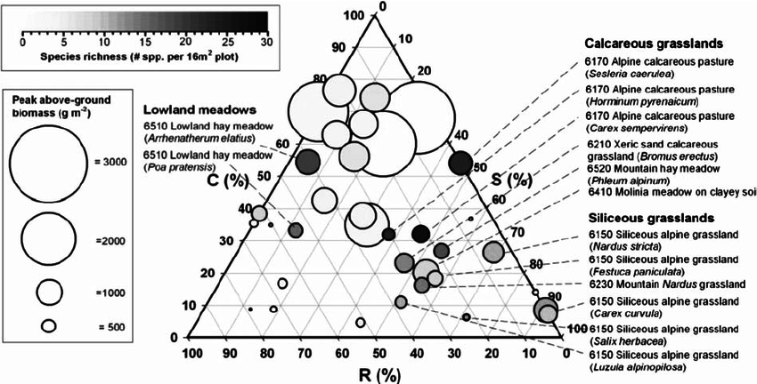

Figure : Extract from Cerabolini 2014, Fig4

Building Plant Functional Group therefore consists of **bringing together plants that have similar traits and strategies** (Fig3, Fig4). Emphasis is placed on **dominant plants** that are supposed to structure the community, and groups are formed according to vegetation strata (and thus height). Soil conditions can also be taken into account (through trait measurement), as well as environmental or climatic conditions (through niche overlap).

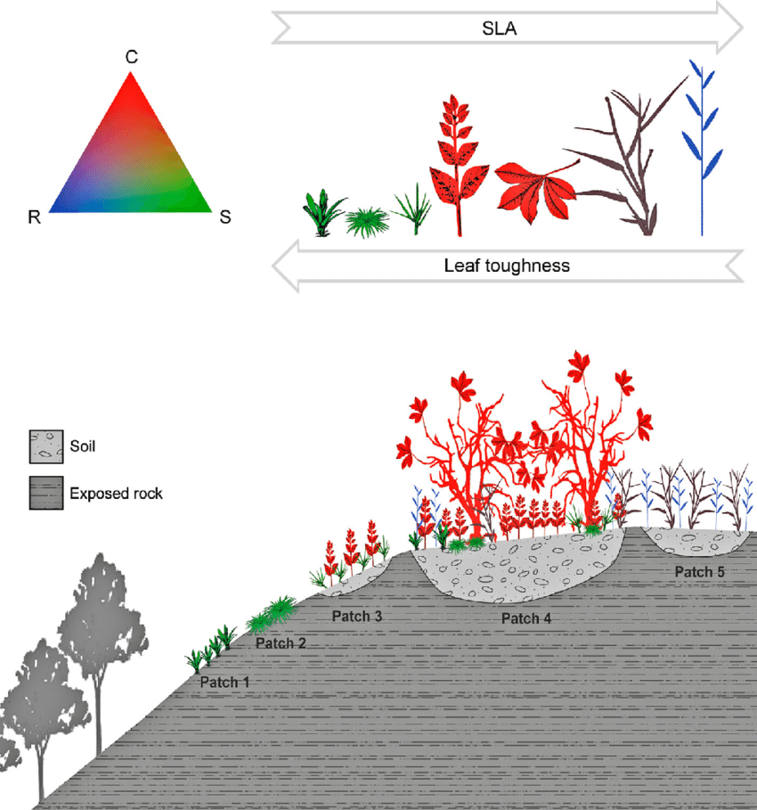

Figure : Extract from de Paula 2015, Fig4

Example of data required ?

Of course, anyone can build functional groups with any trait he wishes, as long as they reflect the strategies he wants to see emerge and study between groups. *Here is a naive example : focusing on desert plants, traits to build the groups could include the height (to distinguish cactus and trees from wildflowers), soil preferences (sand, rocks, tundra), leaf dry matter content (water storage strategy), the flowering type, etc.*

Here is an example of functional traits that can be used to build Plant Functional Group (and parametrize a FATE simulation) (Boulangeat, 2012, Boulangeat, 2014).

* Demographic characteristics :
  + Age at maturity
  + Longevity
  + Raunkiaer’s life forms (Raunkiaer, 1934)
  + Height to represent a proxy for biomass
* Dispersal ability
  + Dispersal classes (Vittoz & Engler, 2007)
* Response to interactions
  + Height to represent the competitive ability for light
  + Indicator value for light requirement (Ellenberg et al. 1991, Landolt et al. 2010)
  + Indicator value for soil requirement (Ellenberg et al. 1991, Landolt et al. 2010)
* Response to disturbances
  + For grazing : palatability index based on pastoral values (Jouglet 1999)
  + For mowing : mowing tolerance

What are the key steps of this process ?

Since the basic idea of building Functional Group is to gather a lot of elements into a few, this implies two requirements :

1. that these elements are not too numerous
2. and that they are representative of the studied area, meaning not rare or outlier elements.  
   **This is the first step : the selection of dominant species.**

In order to identify similarities between selected dominant species in terms of habitat, the climatic or environmental niche of each species is calculated and is compared with all the other dominant species niches.

**The overlap of species environmental niches is obtained in second step.**

Functional traits related to the fundamental process of growth are retrieved for each dominant species and mixed together to calculate functional distances between species.

**Overlap of environmental niches and functional distances are combined to form a matrix of species pairwise distances.**

Finally, based on this distance matrix, **species are clustered to find the best combination and obtain Functional Groups.**

* 1. **Building PFG**
     1. **Selection of dominant species**
* Gather **occurrences** for all species within the studied area
* Identify dominant species based on **abundances and frequençy of sampling**

with the function [PRE_FATE.selectDominant](https://leca-dev.github.io/RFate/reference/PRE_FATE.selectDominant.html)

## Load example data

Champsaur_PFG = .loadData("Champsaur_PFG", "RData")

## Species observations

tab = Champsaur_PFG$sp.observations

## No habitat, no robustness -------------------------------------------------

tab.occ = tab[, c("sites", "species", "abund")]

sp.SELECT = PRE_FATE.selectDominant(mat.observations = tab.occ)

names(sp.SELECT)

str(sp.SELECT$tab.rules)

plot(sp.SELECT$plot.A)

plot(sp.SELECT$plot.B$abs)

plot(sp.SELECT$plot.B$rel)

## Habitat, change parameters, no robustness (!quite long!) --------------------

tab.occ = tab[, c("sites", "species", "abund", "habitat")]

sp.SELECT = PRE_FATE.selectDominant(mat.observations = tab.occ

, doRuleA = TRUE

, rule.A1 = 10

, rule.A2_quantile = 0.9

, doRuleB = TRUE

, rule.B1_percentage = 0.2

, rule.B1_number = 10

, rule.B2 = 0.4

, doRuleC = TRUE)

names(sp.SELECT)

str(sp.SELECT$tab.rules)

plot(sp.SELECT$plot.C)

plot(sp.SELECT$plot.pco$Axis1_Axis2)

plot(sp.SELECT$plot.pco$Axis1_Axis3)

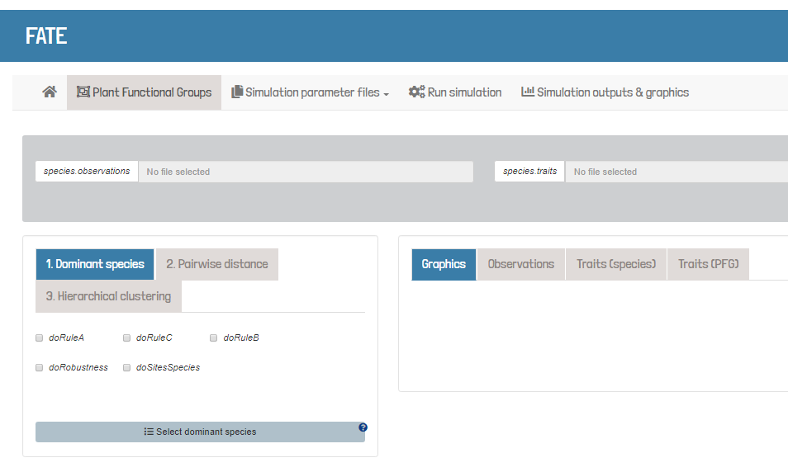

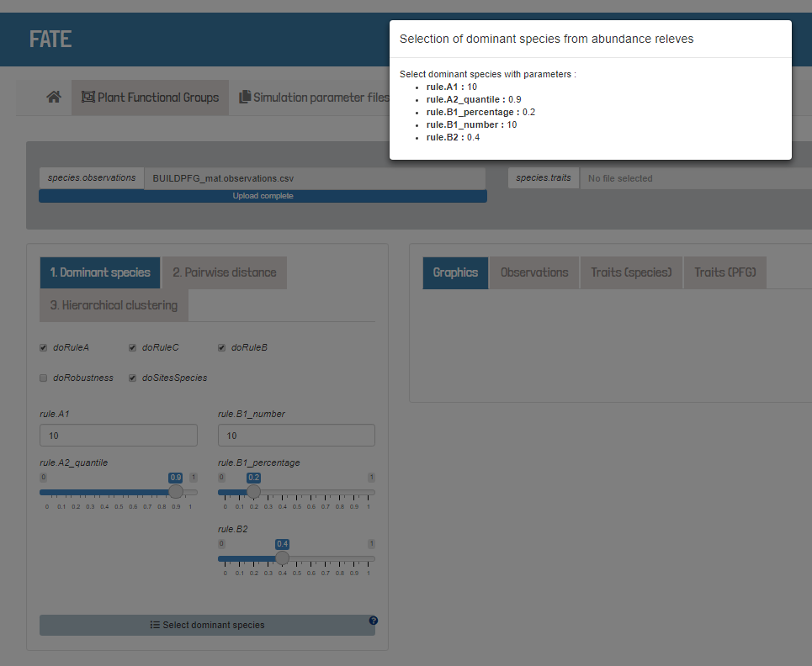

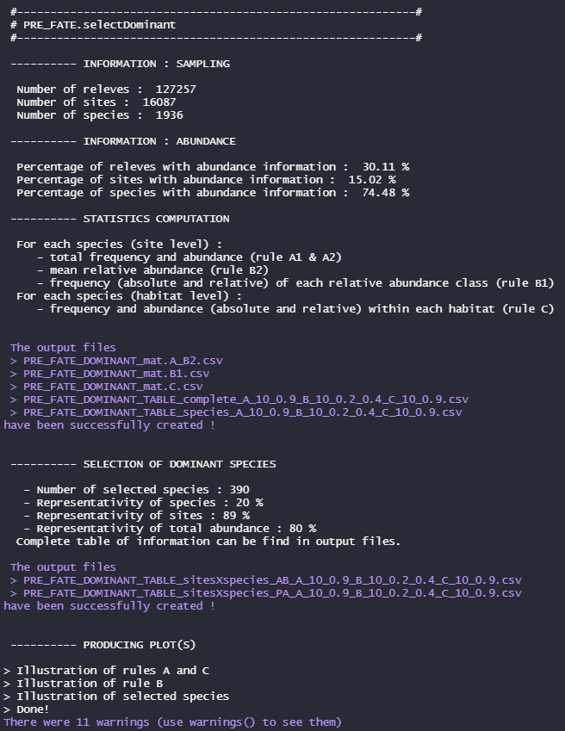

Information provided by the function can help you explore your dataset, both in terms of « *what’s there* » (Fig, 1st orange box : INFORMATION : SAMPLING and INFORMATION : ABUNDANCE parts) and « *what do I select* » (Fig, 2nd orange box : SELECTION OF DOMINANT SPECIES). If you want to use the selection criteria B, it requires abundance information and might be applied only on part of your data. It is up to the user to decide whether this part is sufficiently representative of the whole dataset. As for the species selected, final decision of « *is this set of species representative of dominance inside my dataset* », although a common recommandation for calculating community weighted mean is to have at least a representativity of 80% of the total abundance of the studied area and such a threshold could be similarly used here.

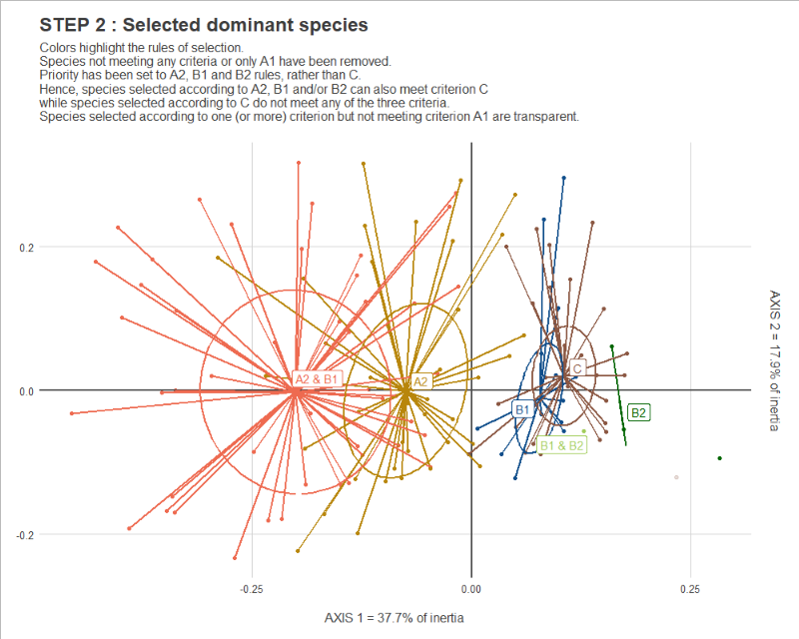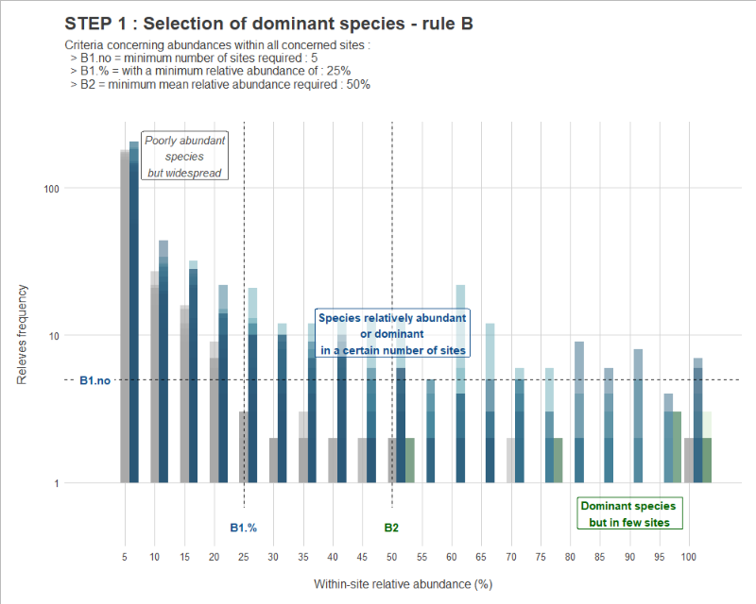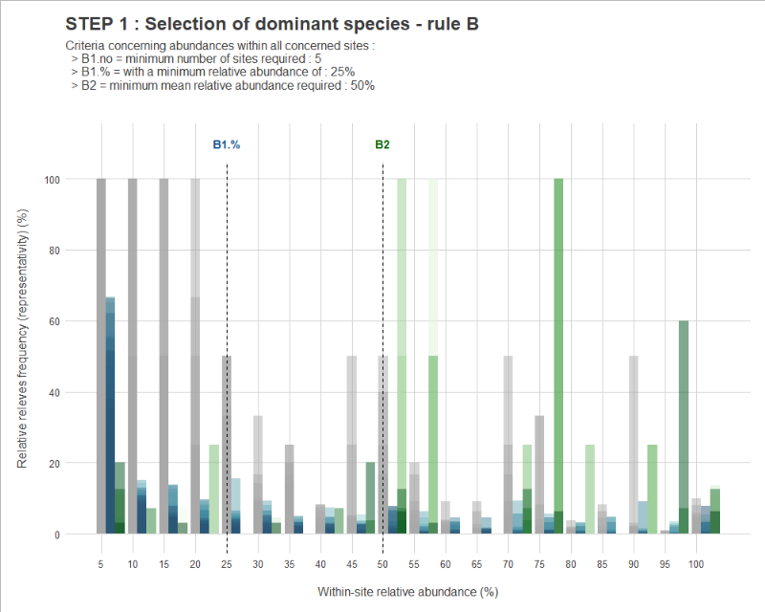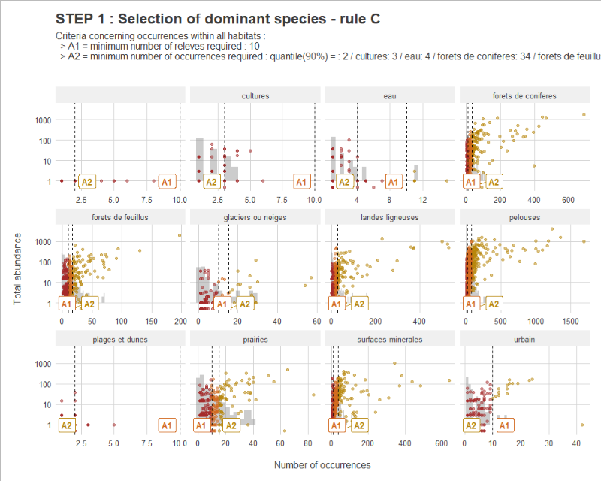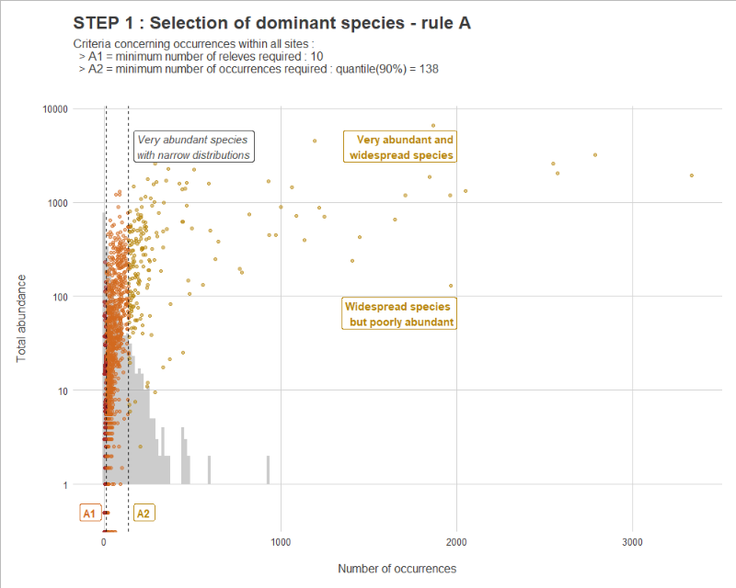

Graphics are produced to help you visualize your species selection, as well as the tables containing the values calculated and used to obtain such selection.

They are automatically saved, as .csv and .pdf files, but the production of plots can be desacti-vated to save some computation time.

Representation into ordination space or phylogeny can help exploring by which criterion the species are selected, and maybe adjusting selection parameter values. *For example, if you decide to use selection criterion C, but no species are selected with it, you might want to change your parameter values. It might also mean that either you do not have species specific to your habitat level, or they might already be selected by A or B criteria.*

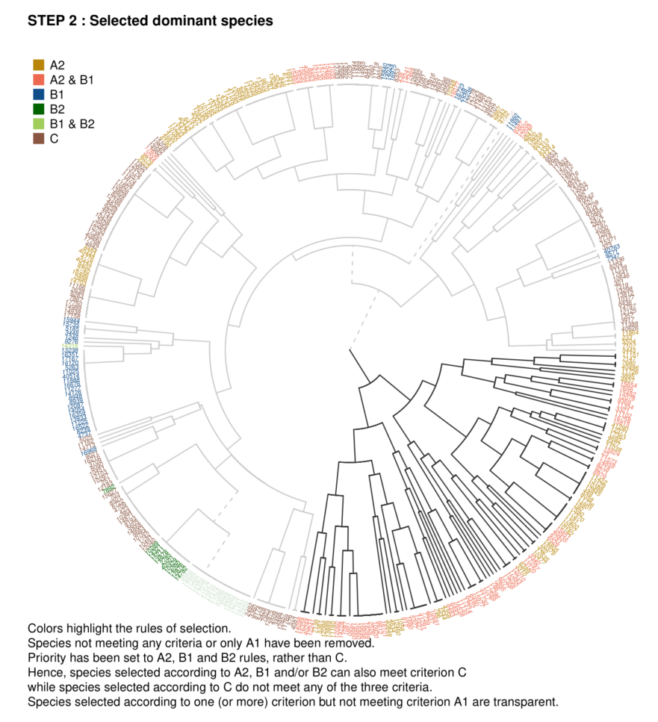

## No habitat, robustness (!quite long!) --------------------

tab.occ = tab[, c("sites", "species", "abund")]

sp.SELECT = PRE_FATE.selectDominant(mat.observations = tab.occ

, opt.doRobustness = TRUE

, opt.robustness_percent = seq(0.1,0.9,0.1)

, opt.robustness_rep = 10)

names(sp.SELECT)

str(sp.SELECT$tab.robustness)

names(sp.SELECT$plot.robustness)

plot(sp.SELECT$plot.robustness$`All dataset`)

The exploratory robustness module was created following a questioning about the robustness of the dominant species selection against changes in the observation dataset. The underlying question was : *for example, if I get my data from an observatory program that updates the dataset every year, is my selection going to change a lot each time I add more observations ?*

Dominant selection can therefore be run, taking only a subset of the observation dataset, removing either single species observations (blue), or complete sites observations (red). The larger (smaller) the values for a/b/c (d/e/f) measures, the lower the impact of removing observations.

* 1. 100% = same number of selected species in S and O
  2. 100% = species in O are all in S (O is included into S)
  3. 100% = species in S are all in O (S is included into O)
  4. 0% = S is identical to O (same number of species + same species)  
      > 0% = difference between S and O
  5. 0% = difference between S and O is enterely due to turnover

> 0% = same species than O, but a subset

* 1. 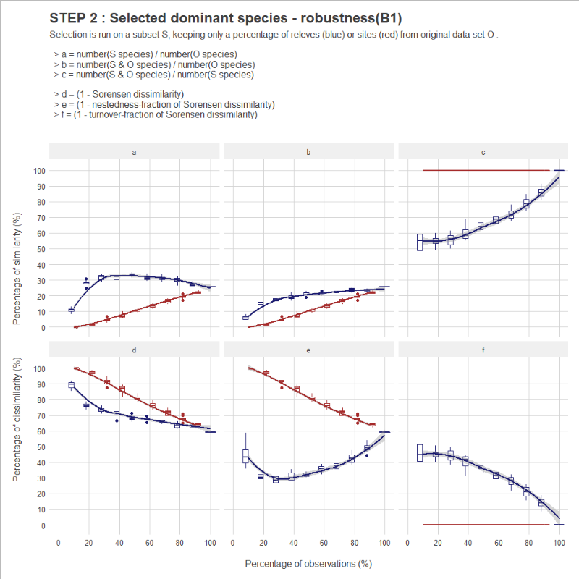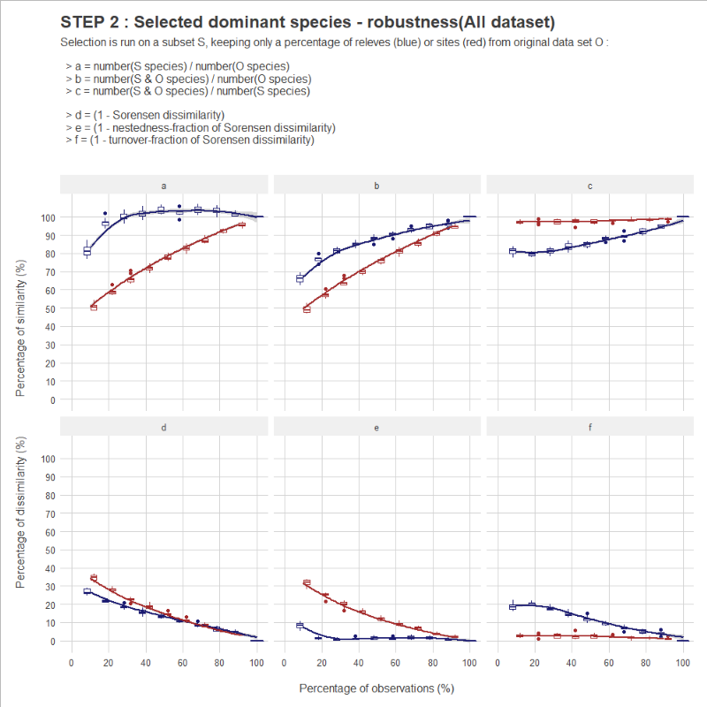 0% = difference between S and O is enterely due to nestedness   
      > 0% = same number of species but some that are different
     1. **Overlap of species environmental niches**
* *Option 1: Principal Component analysis*
  + Gather **environmental data** for the studied area
  + Compute **PCA** over environment to create a *climatic/habitat space*
  + Calculate the **density of each species** within this *climatic/habitat space* from the PCA
  + For each pair of species, compute the **overlap** of the 2 considered species within the *climatic/habitat space*
* *Option 2: Species Distribution Models*
  + Gather **environmental data** for the studied area
  + For each dominant species, compute a **species distribution model** (SDM)
  + combining environmental data and occurrences to determine the *climatic/habitat niche* of the species
  + With these SDMs, calculate the **niche overlap** of each pair of species

This step represents a complete other subject (species distribution modelling and overlap) and other packages are dedicated to these computations (ecospat, biomod2, phyloclim, etc). However, some computations can be made through the [PRE_FATE.speciesDistance](https://leca-dev.github.io/RFate/reference/PRE_FATE.speciesDistance.html) function presented here-after.

* *Option 1* can be realized with the help of the ecospat package, giving a sites by species occurrence matrix (as produced by the [PRE_FATE.selectDominant](https://leca-dev.github.io/RFate/reference/PRE_FATE.selectDominant.html) function) together with a corresponding sites by environment matrix.
* *Option 2* can only be partially executed through the RFate package : a list of species distribution maps can be given to the function and a matrix of niche overlap distances will be calculated with the help of the phyloclim package.

If you do not want to fullfill this step, you can simply build a species by species matrix and fill it with 1 everywhere (meaning that all species share the same environmental niche), and use it for the next step.

* + 1. **Species pairwise distance**

by combining overlap and functional distances with the function [PRE_FATE.speciesDistance](https://leca-dev.github.io/RFate/reference/PRE_FATE.speciesDistance.html)

* Gather **traits data** for all dominant species within the studied area (traits need to be related to fundamental process of growth : light tolerance, dispersal, height…)
* Compute **dissimilarity distances** between pairs of species based on these traits and taking also into account the overlap of the 2 species within the *environmental space* (see previous step)

## Load example data

Champsaur_PFG = .loadData("Champsaur_PFG", "RData")

## Species traits

tab.traits = Champsaur_PFG$sp.traits

tab.traits = tab.traits[, c("species", "GROUP", "MATURITY", "LONGEVITY"

, "HEIGHT", "DISPERSAL", "LIGHT", "NITROGEN")]

str(tab.traits)

## Species niche overlap (dissimilarity distances)

tab.overlap = 1 - Champsaur_PFG$mat.overlap ## transform into similarity

tab.overlap[1:5, 1:5]

## Give warnings -------------------------------------------------------------

sp.DIST = PRE_FATE.speciesDistance(mat.traits = tab.traits

, mat.overlap.option = "dist"

, mat.overlap.object = tab.overlap)

str(sp.DIST)

## Change parameters to allow more NAs (and change traits used) --------------

sp.DIST = PRE_FATE.speciesDistance(mat.traits = tab.traits

, mat.overlap.option = "dist"

, mat.overlap.object = tab.overlap

, opt.maxPercent.NA = 0.05

, opt.maxPercent.similarSpecies = 0.3

, opt.min.sd = 0.3)

str(sp.DIST)

require(foreach); require(ggplot2); require(ggdendro)

pp = foreach(x = names(sp.DIST$mat.ALL)) %do%

{

hc = hclust(sp.DIST$mat.ALL[[x]])

pp = ggdendrogram(hc, rotate = TRUE) +

labs(title = paste0("Hierarchical clustering based on species distance "

, ifelse(length(names(sp.DIST$mat.ALL)) > 1

, paste0("(group ", x, ")")

, "")))

return(pp)

}

plot(pp[[1]])

plot(pp[[2]])

plot(pp[[3]])

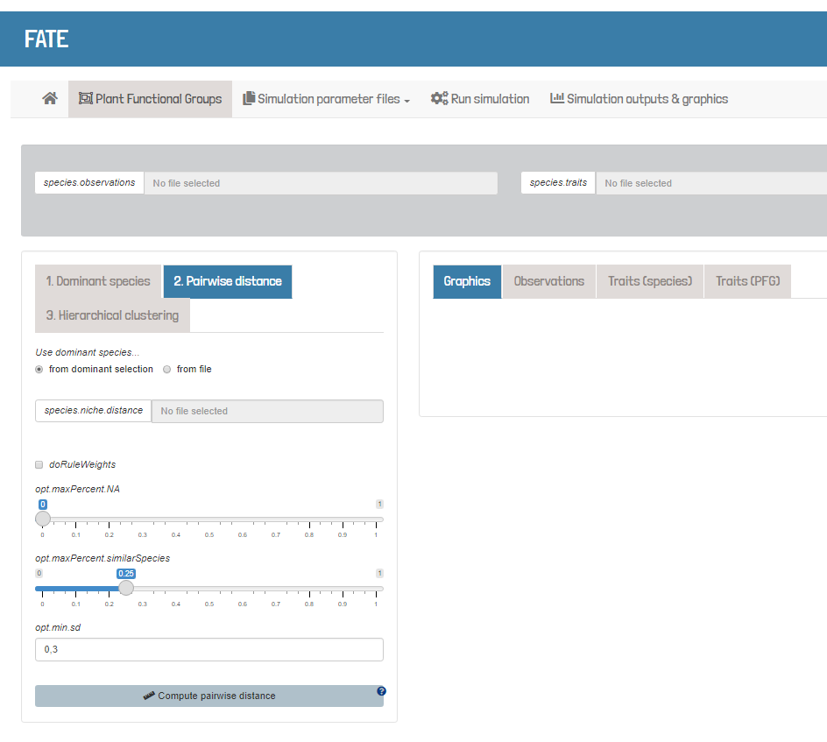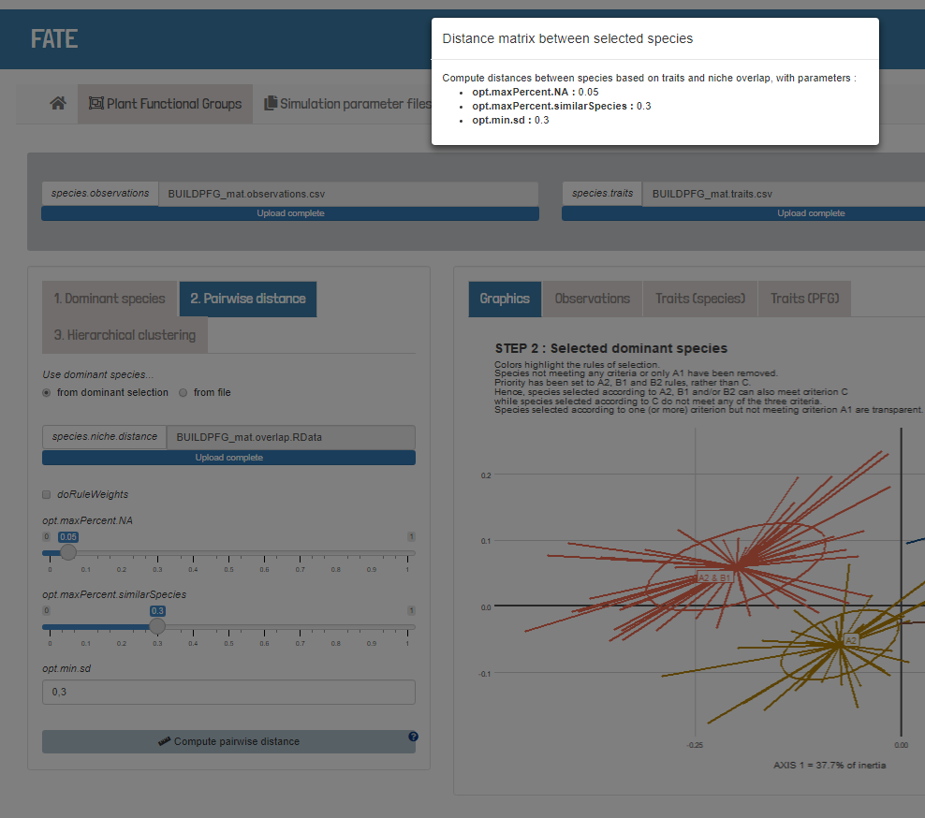

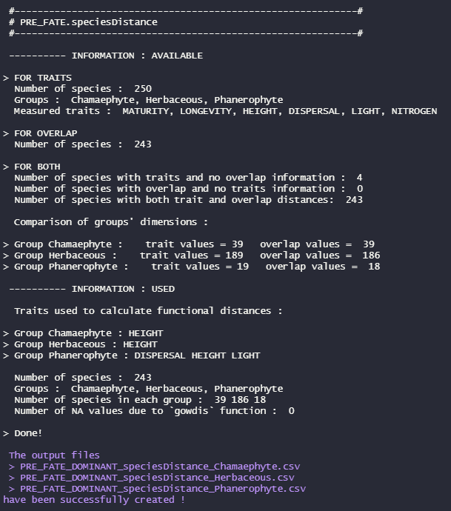

As for the selection of dominant, the computation of species distances returns lot of information to help you explore your traits dataset for your selected species. Once again, in terms of « what’s there » (Fig, 1st orange box : INFORMATION : AVAILABLE part) and « *what do I select* » (Fig, 2nd orange box : INFORMATION : USED).

A distance can only be calculated for a specific species if it has both trait(s) and overlap information. Missing one or the another causes the species to be removed from the calculation. This is reflected into the INFORMATION : AVAILABLE part.

The INFORMATION : USED part indicates the trait(s) *really* used for each group to calculate functional distances. *For example here, only HEIGHT is kept for Chamaephyte, while 6 traits were given as inputs.*

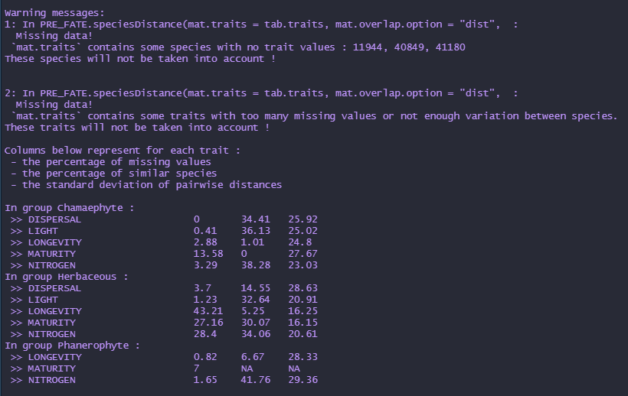

This is a good example why warning messages ARE important and should ALWAYS be carefully checked.

First warning indicates species with no trait values that will be removed from the distance calculation. Second warning gives a table of values for each trait in each group : the percentages of missing values and similar species for the concerned trait, as well as the standard deviation of pairwise distances. They are all compared to parameters of the [PRE_FATE.speciesDistance](https://leca-dev.github.io/RFate/reference/PRE_FATE.speciesDistance.html) function : opt.maxPercent.NA, opt.maxPercent. similarSpecies and opt.min.sd respectively. If a trait does not fullfill the required condition, it is removed from the computation for this specific group. Hence, it is possible not having the same set of traits used between groups. If this is something that you do not want, you just have to fix the function parameters to low tolerance values (*for example : 1, 1 and 0 respectively*).

Once species pairwise distances calculated, they are in the form of species by species matrix, but can be easily represented through dendrograms : it gives an overview of what is going to be done in the following steps.

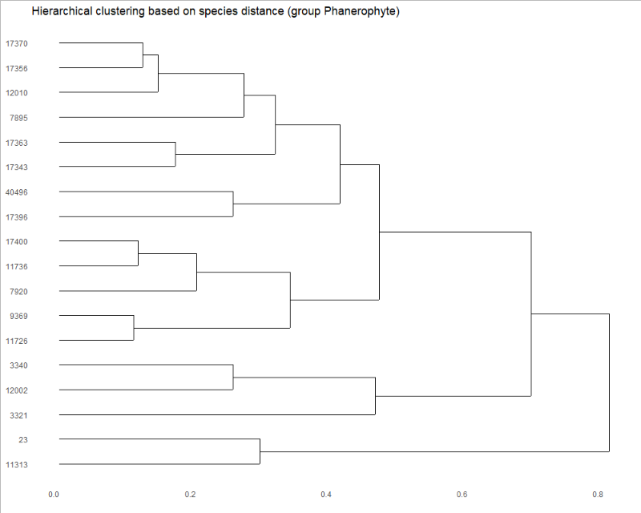The distance matrix obtained (one for each given category, *here 3 : Phanero-phyte, Chamaephyte and Herbaceous*) is classifying species according to the traits used, the overlap distances, and the weights given to these two sources of information.

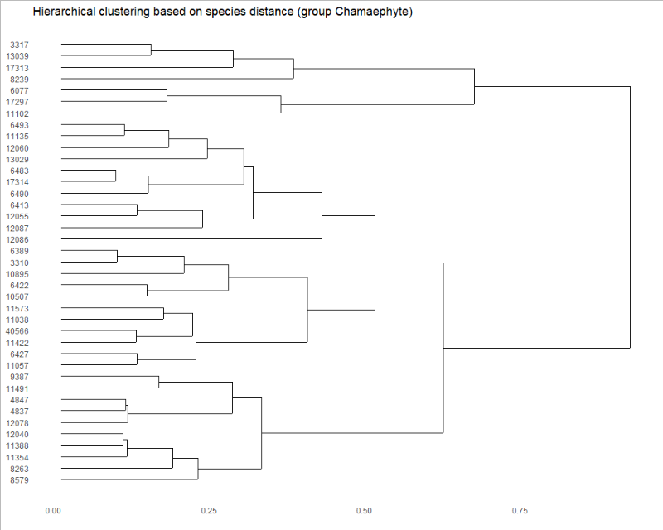Clustering and choice of functional group will just consist in cutting these distance trees at a certain height, thus giving a certain number of groups for each category.

The next function realize this cut and give some information to help the user decide the final number of groups to keep.

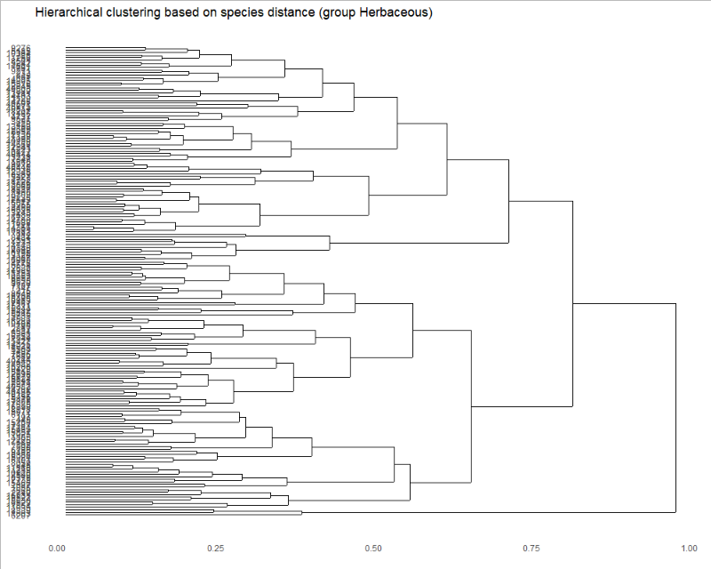

* + 1. **Clustering**

using the **dissimilarity distances** from previous step :

* calculate all possible **clusters**, and the corresponding evaluation metrics with the function [PRE_FATE.speciesClustering_step1](https://leca-dev.github.io/RFate/reference/PRE_FATE.speciesClustering_step1.html)
* choose the best number of clusters from the previous step and find **determinant species** with the function [PRE_FATE.speciesClustering_step2](https://leca-dev.github.io/RFate/reference/PRE_FATE.speciesClustering_step2.html)
* combine traits data and clustering to calculate mean / median trait values per PFG with the function [PRE_FATE.speciesClustering_step3](https://leca-dev.github.io/RFate/reference/PRE_FATE.speciesClustering_step3.html)

## Load example data

Champsaur_PFG = .loadData("Champsaur_PFG", "RData")

## Species dissimilarity distances (niche overlap + traits distance)

tab.dist = list("Phanerophyte" = Champsaur_PFG$sp.DIST.P$mat.ALL

, "Chamaephyte" = Champsaur_PFG$sp.DIST.C$mat.ALL

, "Herbaceous" = Champsaur_PFG$sp.DIST.H$mat.ALL)

str(tab.dist)

as.matrix(tab.dist[[1]])[1:5, 1:5]

## Build dendrograms ---------------------------------------------------------

sp.CLUST = PRE_FATE.speciesClustering_step1(mat.species.DIST = tab.dist)

names(sp.CLUST)

str(sp.CLUST$clust.evaluation)

plot(sp.CLUST$plot.clustMethod)

plot(sp.CLUST$plot.clustNo)

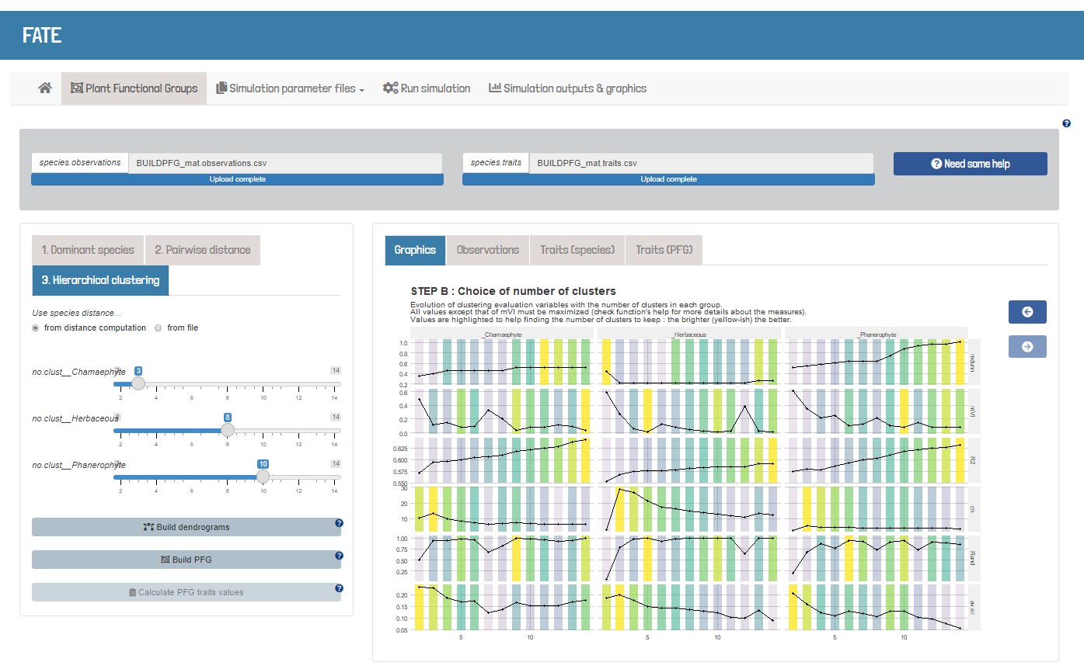

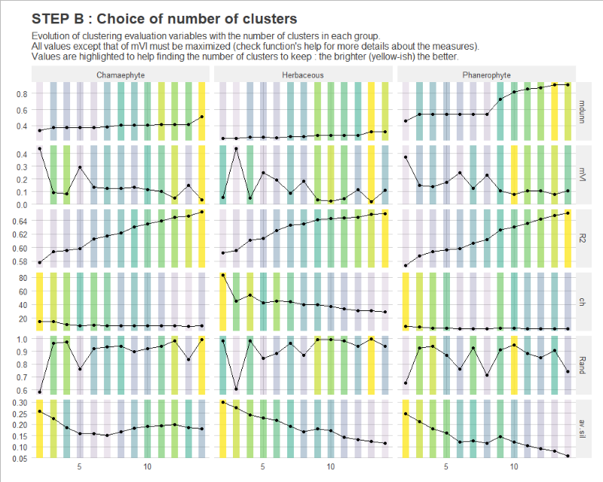 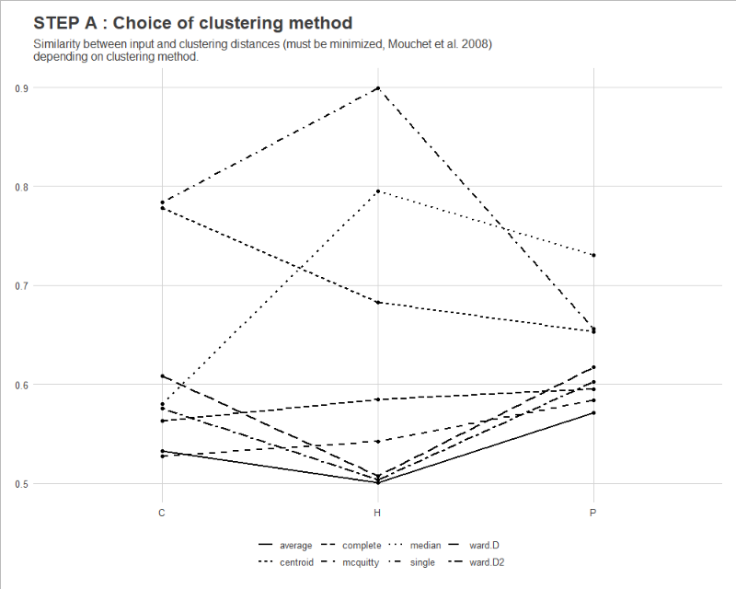

Unfortunately, there are several clustering methods, and several ways of evaluating the quality of the clusters obtained according to the number of groups created. Hence, it is quite difficult to build a method indicating directly by itself the « best » groups that you can get from your matrix of species distances.

The graphic A is purely informative, as you do not have control on this step : the selection of the clustering method (see function’s help for details). The graphic B, however, is produced to help you decide about how many groups you want to keep in the end (and this will be done with the [PRE_FATE.speciesClustering_step2](https://leca-dev.github.io/RFate/reference/PRE_FATE.speciesClustering_step2.html) function). Indeed, when using a distance matrix to do clustering, it is to be decided « at which level » of the hierarchical tree obtained you want to cut and get the subsequent groups.

## Number of clusters per group

plot(sp.CLUST$plot.clustNo)

no.clusters = c(4, 3, 8) ## Phanerophyte, Chamaephyte, Herbaceous

## Find determinant species --------------------------------------------------

sp.DETERM = PRE_FATE.speciesClustering_step2(

clust.dendrograms = sp.CLUST$ clust.dendrograms

, no.clusters = no.clusters

, mat.species.DIST = tab.dist)

names(sp.DETERM)

str(sp.DETERM$determ.sp)

str(sp.DETERM$determ.all)

An additional step of group refinement is also realized with the [PRE_FATE.species Clustering_step2](https://leca-dev.github.io/RFate/reference/PRE_FATE.speciesClustering_step2.html) function. Once the hierarchical trees are cut according to the specified number of groups wanted, within-group distances are calculated to try and identified « outliers » species that will be tagged as **« non determinant » species** (see function’s help for details).

Principal Coordinate Analysis graphics give insights on how the resulting groups are well differencied from each other according to the final distance matrix combining both traits and overlap informations.

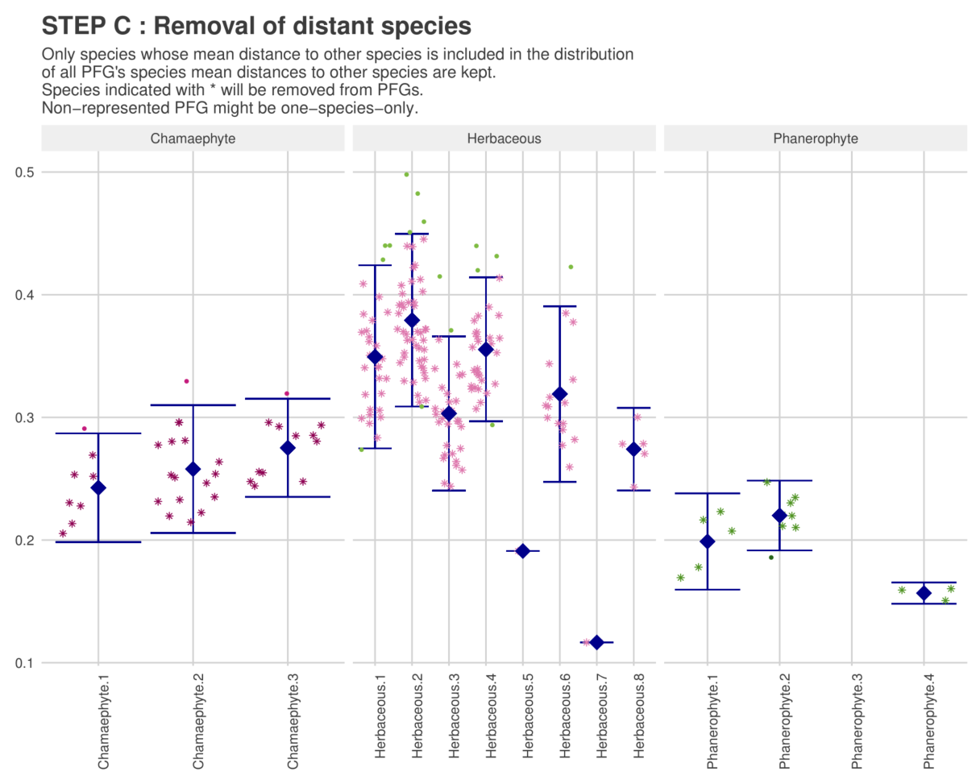

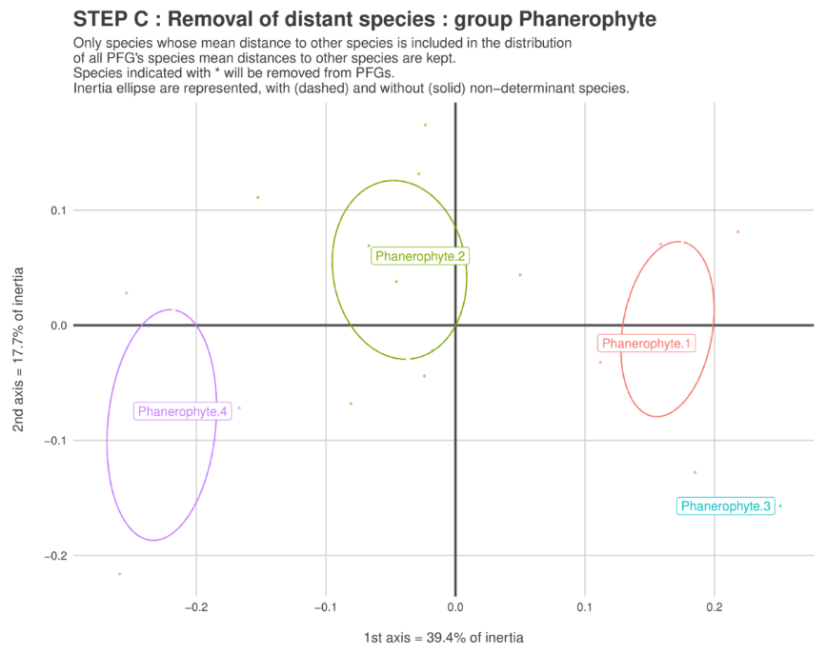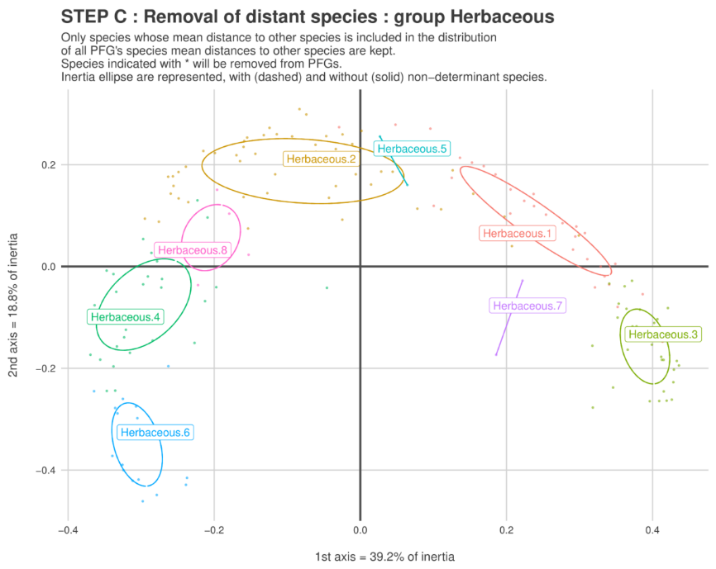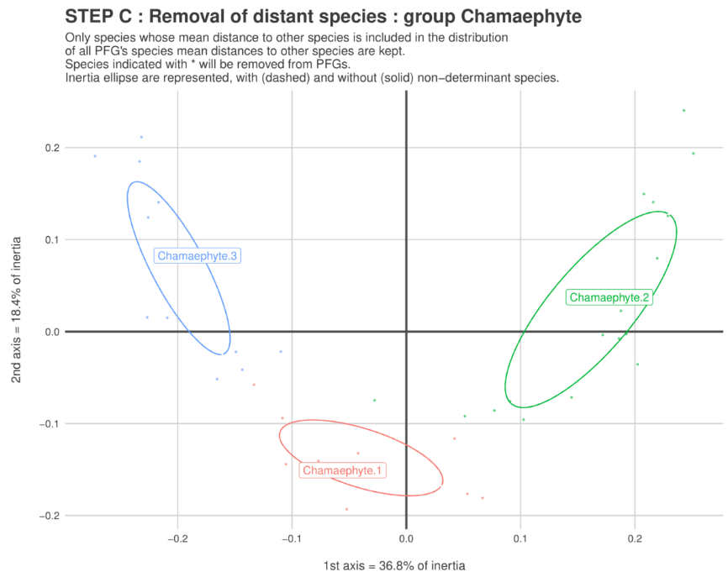

## Load example data

Champsaur_PFG = .loadData("Champsaur_PFG", "RData")

## Species traits

tab.traits = Champsaur_PFG$sp.traits

str(tab.traits)

## Determinant species

tab.PFG = Champsaur_PFG$PFG.species

str(tab.PFG)

## Merge traits and PFG informations

mat.traits = merge(tab.PFG[which(tab.PFG$DETERMINANT==TRUE), c("species","PFG")]

, tab.traits

, by = "species", all.x = TRUE)

str(mat.traits)

## Keep only traits of interest

mat.traits = mat.traits[, c("PFG", "species", "MATURITY", "LONGEVITY"

, "HEIGHT", "LIGHT", "DISPERSAL"

, "NITROGEN", "NITROGEN_TOLERANCE", "LDMC", "LNC")]

colnames(mat.traits) = c("PFG", "species", "maturity", "longevity"

, "height", "light", "dispersal"

, "soil_contrib", "soil_tolerance", "LDMC", "LNC")

mat.traits$soil_contrib = as.numeric(mat.traits$soil_contrib)

mat.traits$soil_tolerance = ifelse(mat.traits$soil_tolerance == 1, 0.5, 1)

## Compute traits per PFG : with one specific graphic ------------------------

PFG.traits = PRE_FATE.speciesClustering_step3(mat.traits = mat.traits)

names(PFG.traits)

str(PFG.traits$tab)

names(PFG.traits$plot)

plot(PFG.traits$plot$maturity_longevity)

plot(PFG.traits$plot$height_light)

plot(PFG.traits$plot$soil)

PFG traits values are computed as the mean (for numeric traits) or the median (for categorical traits) of the group’s species values. The more missing values, the more biased the group values are.

Graphics can help visualize how different (or not) the groups are in the end. *For example, if all PFG have similar light preferences, then you should not expect to the light interaction module to have a huge impact on your simulated vegetation communities.*

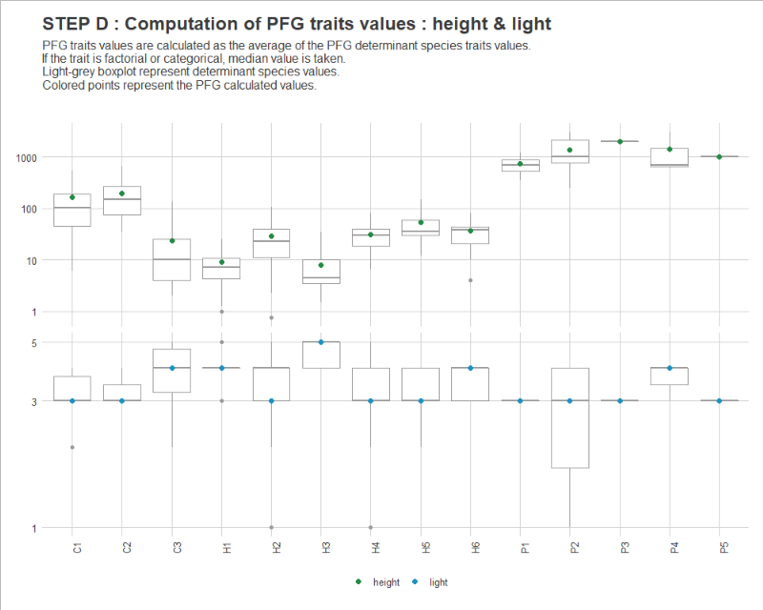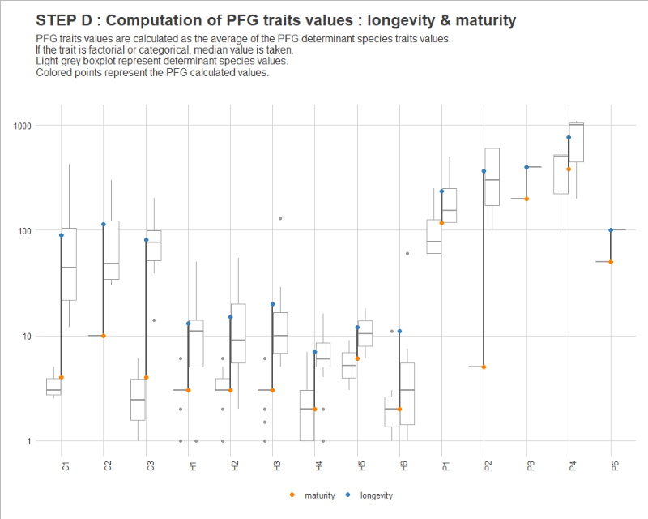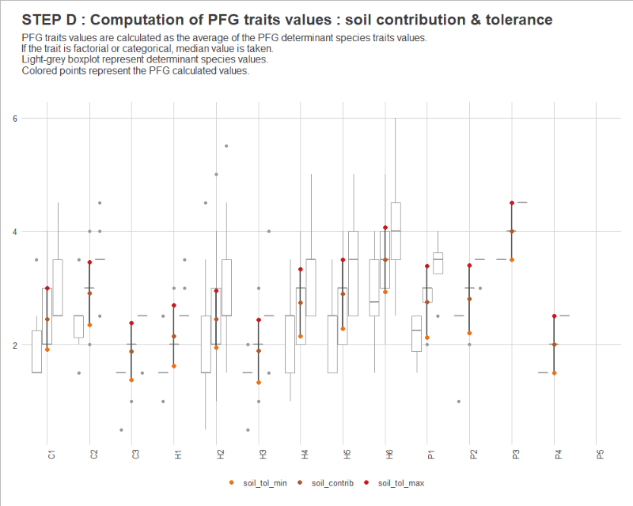

1. **Modelling framework**
   1. **Parameter files**

FATE requires a quite large number of parameters, which are stored into .txt files, presented to and recovered by the software. These **parameters** can be of 3 types :

1. **Filenames**, to guide the application to other parameter files that should be read
2. These filenames either correspond to :
   * other parameter files that contain **values** to be actually read and used
   * **raster files**, with the extension .tif (lighter) or .img

To enumerate these settings, 2 types of flag can be found and used within the parameter files:

1. To give one or several links to other files containing parameter values or to raster files : --PARAM_NAME—

--GLOBAL_PARAMS--

FATE_simulation/DATA/GLOBAL_PARAMETERS/Global_parameters_V1.txt

--MASK--

FATE_simulation/DATA/MASK/mask.tif

--PFG_PARAMS_LIFE_HISTORY--

FATE_simulation/DATA/PFGS/SUCC/SUCC_PFG1.txt

FATE_simulation/DATA/PFGS/SUCC/SUCC_PFG2.txt

...

In this way, each parameter can have several values (filenames), and **each line corresponds to a value**. The transition to a new parameter is made thanks to the presence of a new flag on the next line.

1. To give parameter values : PARAM_NAME

NAME H2_dryGrass

MATURITY 3

LONGEVITY 11

MAX_ABUNDANCE 1

CHANG_STR_AGES 0 10000 10000 10000 10000

...

Each line corresponds to a parameter, given by the **flag** (parameter name in capital letters) **followed by all values linked to this flag on the same line**. Each value has to be separated from another by a **space**.

The FATE friendly directory organization

As FATE needs quite a lot of parameters given into different parameter files, it is important to organize them in a clear and intuitive way. While this is not mandatory to run a FATE simulation, a specific and methodical folder architecture can be obtained with the [PRE_FATE.skeletonDirectory](https://leca-dev.github.io/RFate/reference/PRE_FATE.skeletonDirectory.html) function from the RFate package.

A good way to start is to create this skeleton directory, and then copy or create the needed files inside to have all simulation data into the same place.

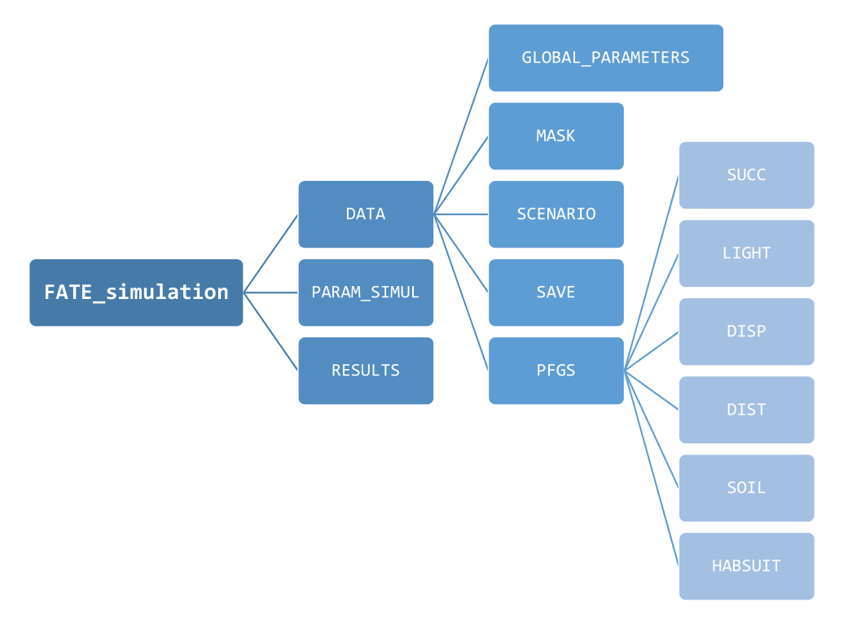

Figure : a FATE simulation directory

The FATE modules

FATE model is built like a LEGO tool : it has a **core module**, which corresponds to the fundamental succession, and then can be complemented with **other modules**. Some of these modules can be regarded as equally important as the core module (from an ecological likelihood point of view, like light, dispersal, soil, etc), and some others are more specific (drought, aliens, fire, etc).

All of these modules require

mandatory parameters

and sometimes, some others that are

optional parameters

that can all be created with RFate functions.

Which files for which settings ?

The function [PRE_FATE.skeletonDirectory](https://leca-dev.github.io/RFate/reference/PRE_FATE.skeletonDirectory.html) allows to create a user-friendly directory tree to store all parameter files and data.

1. *Simulation parameterization*

* **Global parameters :** related to the simulation definition (number of PFG and strata, simulation duration, computer resources, manage abundance values, modules loaded…) with the function [PRE_FATE.params_globalParameters](https://leca-dev.github.io/RFate/reference/PRE_FATE.params_globalParameters.html)
* **Years to save abundance raster maps and simulation outputs**   
  with the function [PRE_FATE.params_saveYears](https://leca-dev.github.io/RFate/reference/PRE_FATE.params_saveYears.html)
* **Years and files to change rasters** for the succession, habitat suitability or disturbance modules with the function [PRE_FATE.params_changingYears](https://leca-dev.github.io/RFate/reference/PRE_FATE.params_changingYears.html)

1. *For each PFG : behavior and characteristics*

* **Succession files :** related to the life history   
  with the function [PRE_FATE.params_PFGsuccession](https://leca-dev.github.io/RFate/reference/PRE_FATE.params_PFGsuccession.html)
* **Dispersal files :** related to the dispersal ability   
  with the function [PRE_FATE.params_PFGdispersal](https://leca-dev.github.io/RFate/reference/PRE_FATE.params_PFGdispersal.html)
* **Light files :** related to the light interaction   
  with the function [PRE_FATE.params_PFGlight](https://leca-dev.github.io/RFate/reference/PRE_FATE.params_PFGlight.html)
* **Soil files :** related to the soil interaction with the function [PRE_FATE.params_PFGsoil](https://leca-dev.github.io/RFate/reference/PRE_FATE.params_PFGsoil.html)
* **Disturbance files :** related to the response to perturbations in terms of resprouting and mortality with the function [PRE_FATE.params_PFGdisturbance](https://leca-dev.github.io/RFate/reference/PRE_FATE.params_PFGdisturbance.html)
* **Drought files :** related to the response to drought in terms of resprouting and mortality with the function [PRE_FATE.params_PFGdrought](https://leca-dev.github.io/RFate/reference/PRE_FATE.params_PFGdrought.html)

1. *Parameter management*

* **SimulParameters file :** containing all links to the files created with the previous functions. This is the file that will be given as the only argument to the [FATE](https://leca-dev.github.io/RFate/reference/FATE.html) function. It can be created with the function [PRE_FATE.params_simulParameters](https://leca-dev.github.io/RFate/reference/PRE_FATE.params_simulParameters.html)
* **Multiple set of files :** to duplicate simulation folder and scan global parameters space with Latin Hypercube Sampling.   
  Folders can be created with the function [PRE_FATE.params_multipleSet](https://leca-dev.github.io/RFate/reference/PRE_FATE.params_multipleSet.html)
  1. **Core module (succession)**

« *Based on the ‘FATE’ model (Moore & Noble, 1990), it describes the within-pixel succession dynamics in an annual time step. […] Five processes describe PFG demography (germination, recruitment, growth, survival and fecundity, see Table 1).* » (Boulangeat, 2014)

* + 1. **Conceptual diagram**

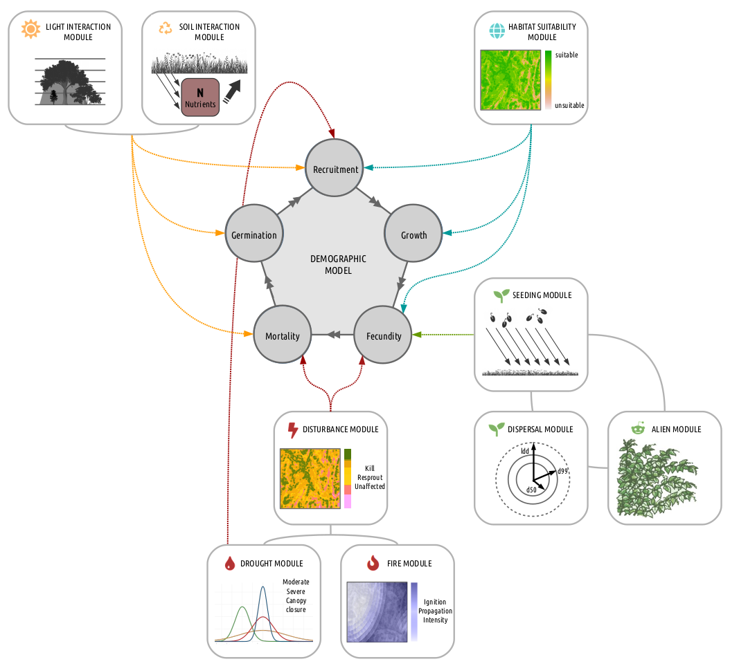

Figure : FATE conceptual diagram

The whole area is divided in grid-cells in which an independent **demographic model** regulates the PFG life cycle. PFG abundances are structured by age into cohorts and each cohort is attributed to a height stratum according to the growth parameters.

Different submodels affect this cycle at various levels (Fig6) :

* **Interaction through light and/or soil resources** regulates interactions between cohorts affecting germination, recruitment and survival.
* **Habitat suitability** affects the recruitment and fecundity rates.
* The **seed dispersal** model makes FATE spatially explicit by connecting grid-cells. It depends on the amount of seeds produced by mature plants and affects each PFG’s seed bank in each cell.
* **Disturbances** affect PFG survival and fecundity.
  + 1. **Life cycle of each PFG and influences from sub-models**

Only three age classes are considered : **germinant**, **juvenile** and **mature**, and can be impacted by the different sub-models activated during the simulation (Fig7) :

* The **recruitment** is influenced by the habitat suitability and the biotic interactions.
* **Mortality** occurs when light or soil conditions are not favorable or when the PFG completes its life span.
* In addition, the disturbance regime directly affects juvenile or mature PFG and may for instance result in PFG death, impede **seed production** by reducing mature PFG age to N-1, or **revitalize senescents** by reducing their age to M-1.

The **timestep** is at the **year** level : seasonality is not included within each timestep, but communities go through 4 states (Fig8) :

1. **Check of survival** : what are the pixel resources (in terms of light and soil) of the previous year, and can the PFG stand them ?
2. All PFG **grow one-year older**, and too old PFG die.
3. **New pixel resources** (in terms of light and soil) are calculated with the actual community, as well as the **seeds produced**. **Recruitment** of new individuals from the previous pool of seeds occurs.
4. If some perturbations are defined, community is impacted in function of the **PFG responses to the disturbance(s)**.

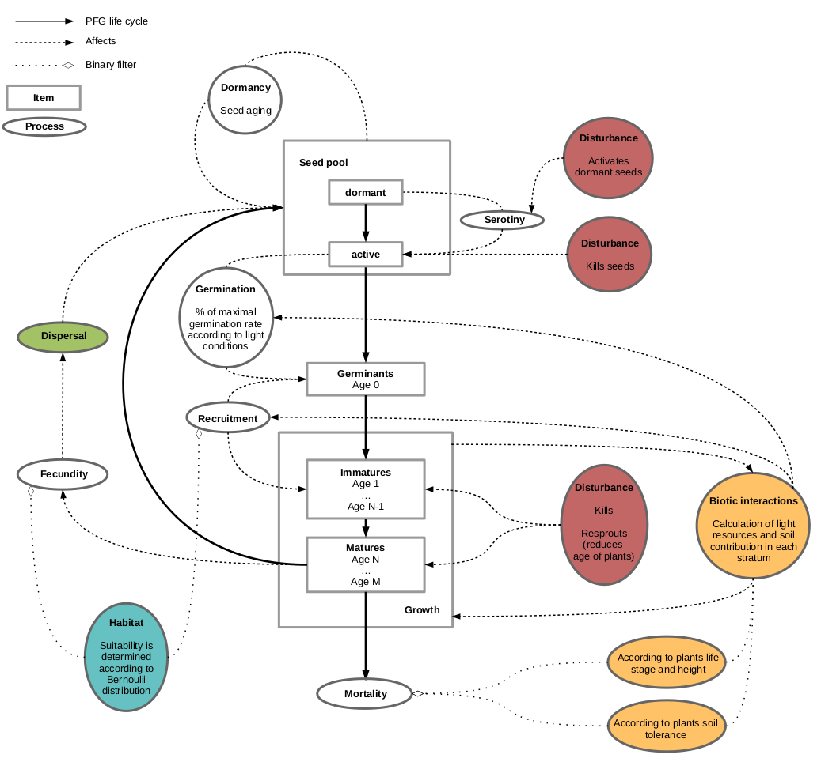

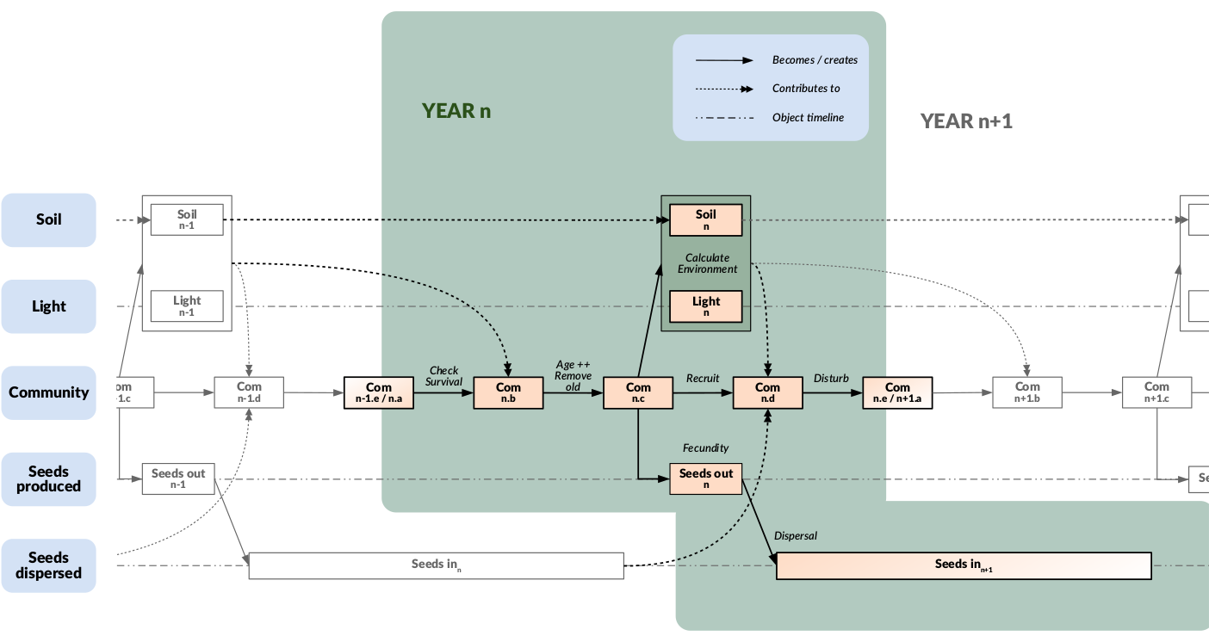Figure : FATE life cycle  
Figure : FATE timeline diagram

* + 1. **Calculation of pixel resources**

Light and soil resources are **proportional to the abundance of the PFG community** of the pixel. They are both converted into **qualitative classes** (Low, Medium or High), for each **height stratum** (concerning light) and for each **PFG** (according to its tolerance, regarding soil). The response of each PFG to each resource level is defined **in function of age** (Germinant, Immature and Mature), in a semi-binary way for light (Fig9), and in a more quantitative way for soil (Fig10).

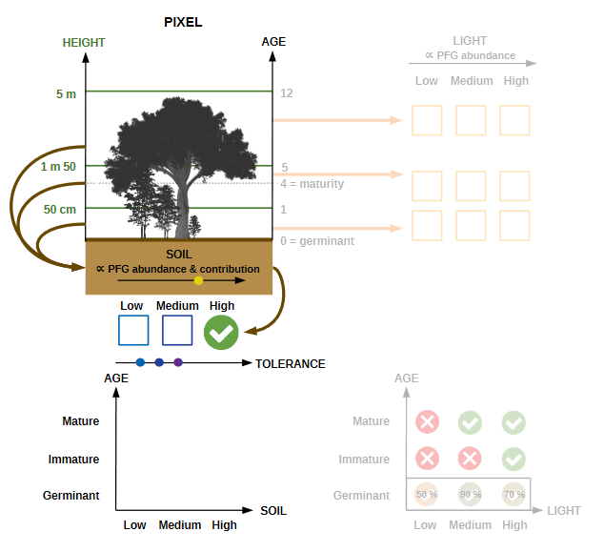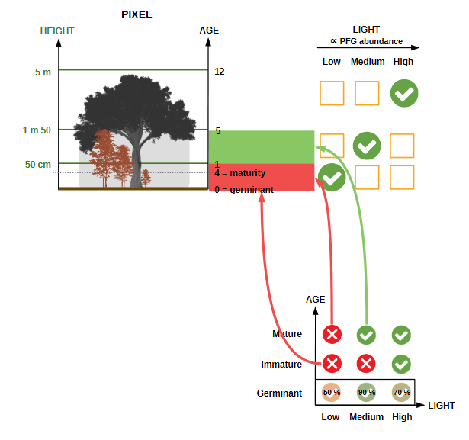

Figure 10: Calculation of FATE resources (soil)

Figure 9: Calculation of FATE resources (light)

* + 1. **Structural equations**

**Internal processes within FATE** are presented on Fig11. Its full understanding by the user is not required or mandatory for the proper use of the software. However, it can help understand the few structural equations integrated in FATE and bring a better appreciation of the overall functioning. Key parameters and functions are progressively presented below in order to appreciate the structural equations.

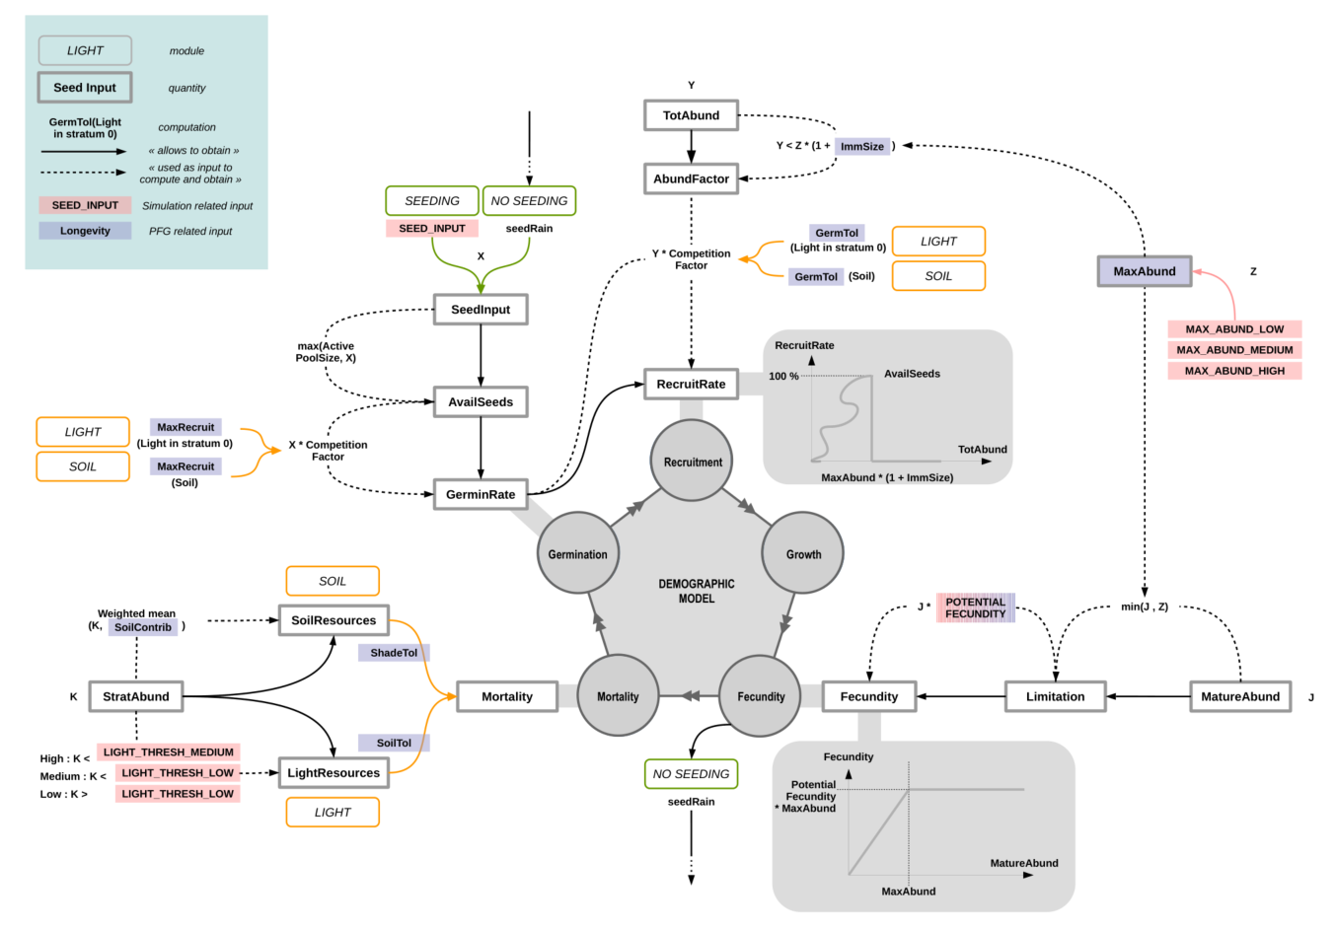

Figure 11: FATE internal processes

Influence of environment (habitat suitability)

* $getEnv…()$**functions :**

All the $getEnv...()$ functions represent the influence of the habitat suitability if the module is selected (see DO_HABITAT_SUITABILITY parameter in [GlobalParameter](https://leca-dev.github.io/RFate/reference/PRE_FATE.params_globalParameters.html) file).

They can have effect on different processes, such as mortality, recruitment or fecundity, depending on whether the habitat within the pixel is suitable or not for the considered PFG.

* **Is the habitat suitable ?**

Each year (timestep), the values contained in each PFG habitat suitability maps will be compared to a reference value :

* + if superior, the environment is considered suitable for the PFG

(hence $getEnv...()$ functions will return 1)

* + otherwise, the environment is considered unsuitable for the PFG

(hence $getEnv...()$ functions will return 0)

Depending on the parameterisation chosen, (see HABSUIT_OPTION parameter in [GlobalParameter](https://leca-dev.github.io/RFate/reference/PRE_FATE.params_globalParameters.html) file), the reference value can be set in two different ways.

Lifespan & maturity :

* **Lifespan :**

In theory, the lifetime of a species could be influenced by the environment, but this is currently not the case. Hence, habitat or not, $getEnvMort()=1$.

$$LifeSpan*getEnvMort()$$

* **Maturity time :**

The time from which a PFG is able to produce seeds can also be influenced by its habitat, in a negative way :

$$maturityTime=(LifeSpan-Maturity)*(1.0-getEnvGrowth())+Maturity$$

$$maturityTime=ceil(maturityTime)$$

If DO_HABITAT_SUITABILITY model is NOT selected, or the habitat is suitable, then $maturityTime=Maturity$. Otherwise, it the habitat is NOT suitable, $maturityTime=LifeSpan$, which means there will be no fecundity, and then no seeds produced.

Carrying capacity (mature vs immature) :

* **Immature :**

Depending on the PFG life-form (herbaceous, chamaephytes, phanerophytes), immature individuals may no take as much space as mature individuals (e.g. young tree vs old tree). Hence, when calculating total abundance of plants, which is used as a proxy of space occupation, abundance of immature individuals is weighted by their relative size compare to mature individuals : $ImmSize$ (see IMM_SIZE parameter in [Succession](https://leca-dev.github.io/RFate/reference/PRE_FATE.params_PFGsuccession.html) files).

* **Mature - Global carrying capacity :**

$MaxAbund∈1,2,3$ defines the maximum abundance that can be reached by a mature PFG. It should be inversely proportional to the space that the PFG can occupy, with taller PFG generally having fewer individuals than for example herbaceous within the same space (see MAX_ABUNDANCE parameter in [Succession](https://leca-dev.github.io/RFate/reference/PRE_FATE.params_PFGsuccession.html) files). It is converted to abundance-related values when contributing to structural equations (see MAX_ABUND_{...} parameters in [GlobalParameter](https://leca-dev.github.io/RFate/reference/PRE_FATE.params_globalParameters.html) file).

Germination :

* **Condition on carrying capacity :**

A condition is set to help regulate populations : new individuals only grow if there is not yet too many individuals within the pixel, i.e. if the total abundance of the PFG does not exceed its global carrying capacity :

$$totAbund=MatureAbund+ImmatureAbund*ImmSize$$

$$globalCC =MaxAbund+MaxAbund*ImmSize$$

* **Condition on pixel resources :**

$MaxRecruit$ corresponds to percentage of seeds that will germinate depending on the pixel resources (light, soil) in stratum 0 (which represents the enforced dormancy) (see ACTIVE_GERM parameter in [Light](https://leca-dev.github.io/RFate/reference/PRE_FATE.params_PFGlight.html) and [Soil](https://leca-dev.github.io/RFate/reference/PRE_FATE.params_PFGsoil.html) files). The number of germinating seeds is obtained by weighting the number of available seeds by this germination rate.

If the module is selected (see DO_HABITAT_SUITABILITY parameter in [Global Parameter](https://leca-dev.github.io/RFate/reference/PRE_FATE.params_globalParameters.html) file), the habitat must be suitable, otherwise the recruitment will be null.

$$RecruitmentRate=GerminationRate * getEnvRecrRate()$$

$$=AvailSeeds*MaxRecruitment * getEnvRecrRate()$$

Fecundity :

* **Potential fecundity :**

Each PFG can produce a fixed amount of seeds per individual (see POTENTIAL_FECUNDITY parameter in [Succession](https://leca-dev.github.io/RFate/reference/PRE_FATE.params_PFGsuccession.html) files). Due to lack of empirical data, this amount is often set at the same value for all PFG.

* **Produced seeds :**

At each time step, the number of seeds that will be produced by a PFG depends both on the number of mature individuals of this PFG within the considered pixel, and on the suitability of the pixel if the module is selected (see DO_HABITAT_ SUITABILITY parameter in [GlobalParameter](https://leca-dev.github.io/RFate/reference/PRE_FATE.params_globalParameters.html) file) (no seeds produced if the habitat is not suitable) :

$$Fecundity=min(MatureAbund, MaxAbund)*PotentialFecund*getEnvFecund()$$

If $MatureAbund⩾MaxAbund$, the PFG has reached its annual carrying capacity : it is in optimal conditions and will produce its maximum amount of seeds ($MaxAbund*PotentialFecund$). Otherwise, this amount will be reduced in proportion.

ANNUAL SEED CYCLE : (*combining all previous information*)

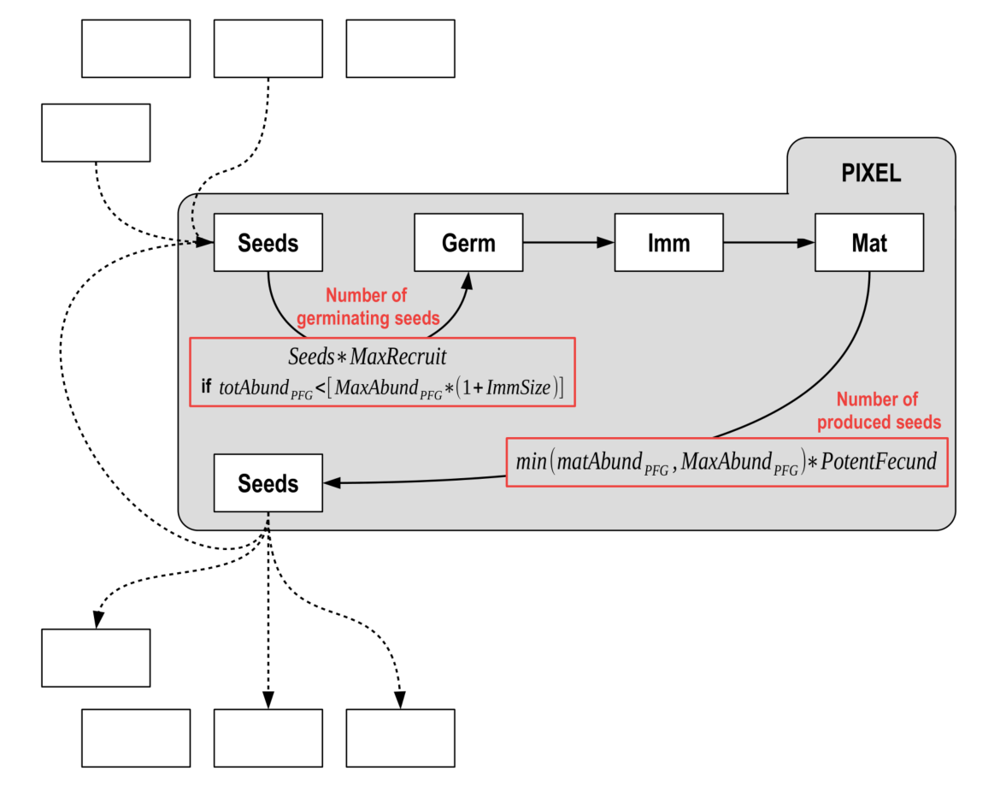  
Germination occurs depending on the current abundance of the PFG inside the pixel : if it reaches the carrying capacity of the PFG $= MaxAbund*(1+ImmSize)$, no seed germinates. The number of produced seeds is proportional to the current abundance of mature individuals only.

Figure 12: FATE annual seed cycle

Required parameters :

* In [GlobalParameters](https://leca-dev.github.io/RFate/reference/PRE_FATE.params_globalParameters.html) file :

NO_PFG 16

NO_STRATA 6

SIMULATION_DURATION 950

SEEDING_DURATION 300

SEEDING_TIMESTEP 1

SEEDING_INPUT 100

POTENTIAL_FECUNDITY 10

MAX_ABUND_LOW 1000

MAX_ABUND_MEDIUM 5000

MAX_ABUND_HIGH 8000

The number of computer resources can also be given. If so, some parts of the main loop of the code will be parallelized on the amount of indicated resources.

NO_CPU 6

Finally, several parameters are available to select which outputs should be saved on when running the simulation :

SAVING_ABUND_PFG_STRATUM 1

SAVING_ABUND_PFG 1

SAVING_ABUND_STRATUM 0

## Create a skeleton folder with the default name ('FATE_simulation') --------

PRE_FATE.skeletonDirectory()

## Create a Global_parameters file--------------------------------------------

PRE_FATE.params_globalParameters(name.simulation = "FATE_simulation"

, opt.saving_abund_PFG_stratum = TRUE

, opt.saving_abund_PFG = TRUE

, opt.saving_abund_stratum = FALSE

, required.no_PFG = 16

, required.no_strata = 6

, required.simul_duration = 950

, required.seeding_duration = 300

, required.seeding_timestep = 1

, required.seeding_input = 100

, required.potential_fecundity = 10

, required.max_abund_low = 1000

, required.max_abund_medium = 5000

, required.max_abund_high = 8000)

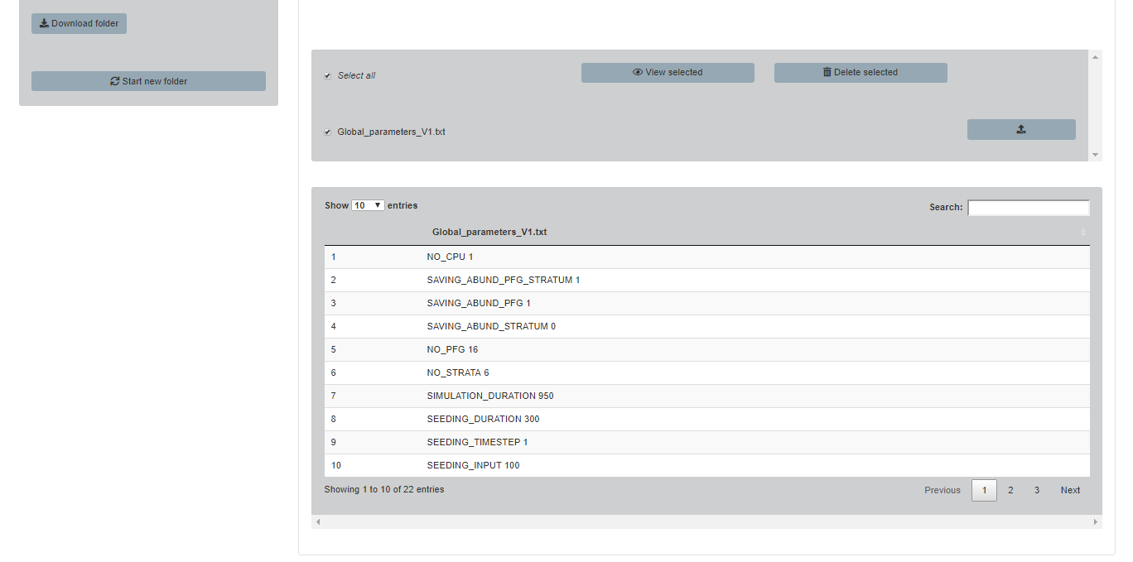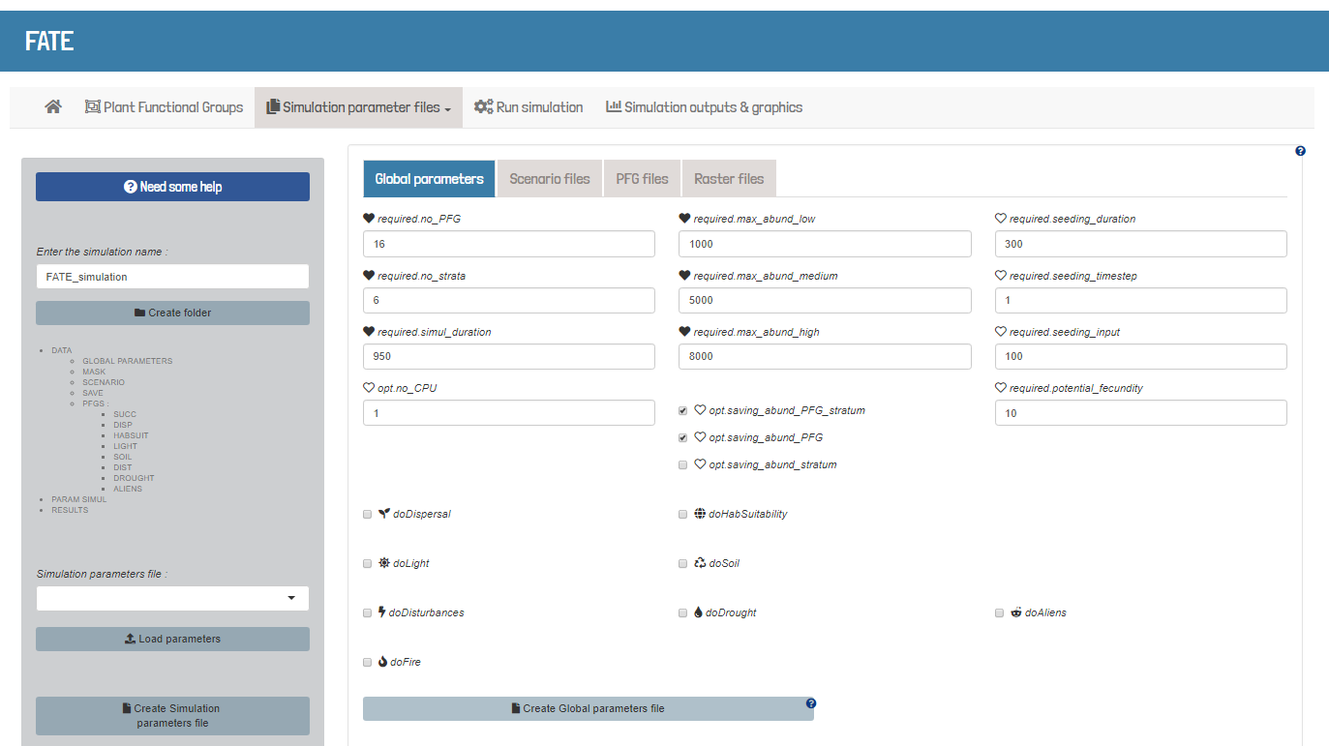

* In [SimulParameters](https://leca-dev.github.io/RFate/reference/PRE_FATE.params_simulParameters.html) file :

--GLOBAL_PARAMS--

FATE_simulation/DATA/GLOBAL_PARAMETERS/Global_parameters_V1.txt

--SAVING_DIR--

FATE_simulation/RESULTS/SIMUL_1/

--MASK--

FATE_simulation/DATA/MASK/mask.tif

--PFG_PARAMS_LIFE_HISTORY--

FATE_simulation/DATA/PFGS/SUCC/SUCC_PFG1.txt

FATE_simulation/DATA/PFGS/SUCC/SUCC_PFG2.txt

--END_OF_FILE--

The years for which must be saved abundance maps for each PFG can also be indicated, as well as years to save a copy of the simulation object :

--SAVING_YEARS_ARRAYS--

FATE_simulation/DATA/SAVE/SAVE_YEARS_maps.txt

--SAVING_YEARS_OBJECTS--

FATE_simulation/DATA/SAVE/SAVE_YEARS_objects.txt

## Create a skeleton folder with the default name ('FATE_simulation') --------

PRE_FATE.skeletonDirectory()

## Create a SAVE_year_maps or/and SAVE_year_objects parameter file -----------

PRE_FATE.params_savingYears(name.simulation = 'FATE_simulation'

, years.maps = c(100, 150, 200)

, years.objects = 200)

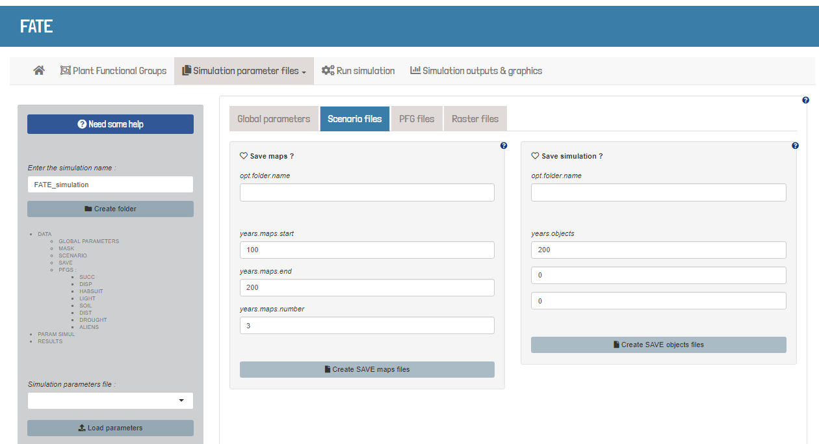

* In [SUCCESSION](https://leca-dev.github.io/RFate/reference/PRE_FATE.params_PFGsuccession.html) files (given with the --PFG_PARAMS_LIFE_HISTORY-- flag in *SimulParameters* file) :

NAME PFG1

TYPE P

HEIGHT 1200

MATURITY 45

LONGEVITY 451

MAX_STRATUM 5

MAX_ABUNDANCE 3

IMM_SIZE 1

CHANG_STR_AGES 0 14 38 110 344

SEED_POOL_LIFE 0 0

SEED_DORMANCY 0

The maximum number of seeds produced each year can also be specified per PFG :

POTENTIAL_FECUNDITY 50

## Load example data

Champsaur_params = .loadData("Champsaur_params", "RData")

## Create a skeleton folder

PRE_FATE.skeletonDirectory(name.simulation = 'FATE_Champsaur')

## PFG traits for succession

tab.succ = Champsaur_params$tab.SUCC

str(tab.succ)

## Create PFG succession parameter files -------------------------------------

PRE_FATE.params_PFGsuccession(name.simulation = 'FATE_Champsaur'

, mat.PFG.succ = tab.succ)

## Create PFG succession parameter files (fixing strata limits) --------------

PRE_FATE.params_PFGsuccession(name.simulation = 'FATE_Champsaur'

, mat.PFG.succ = tab.succ

, strata.limits = c(0, 20, 50, 150, 400, 1000, 2000)

, strata.limits_reduce = FALSE)

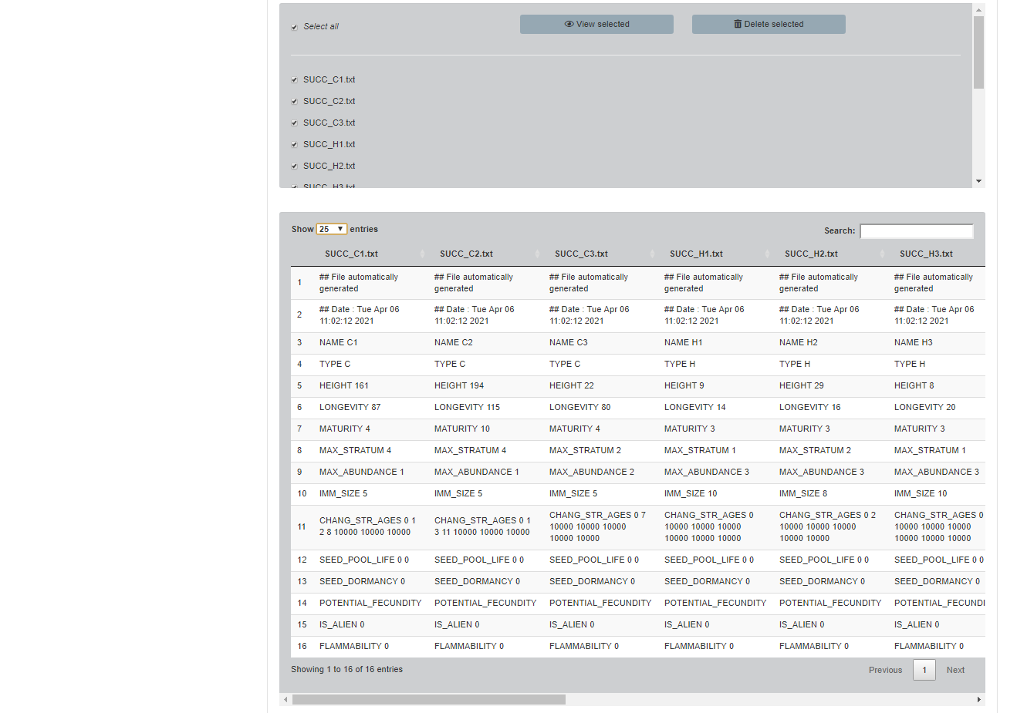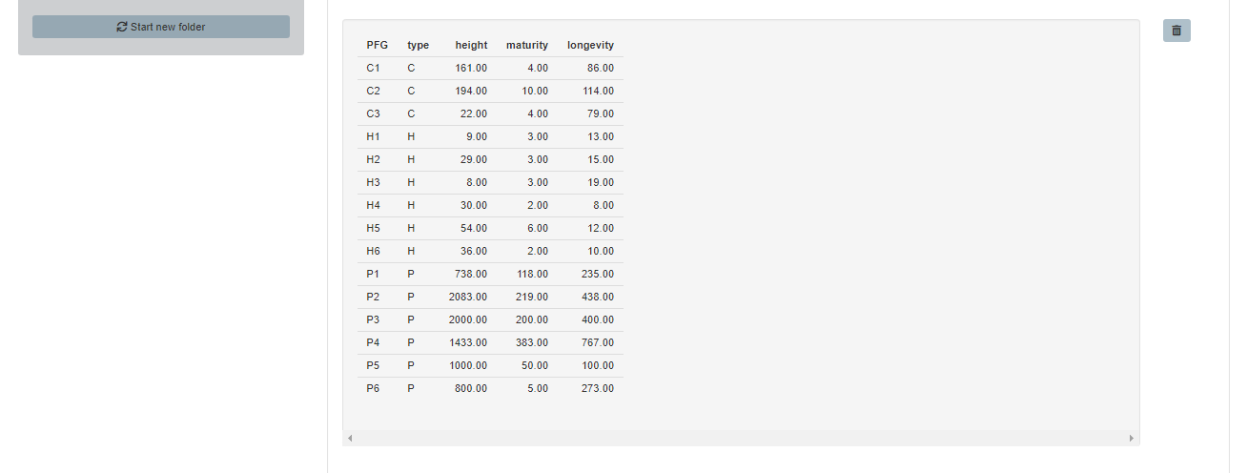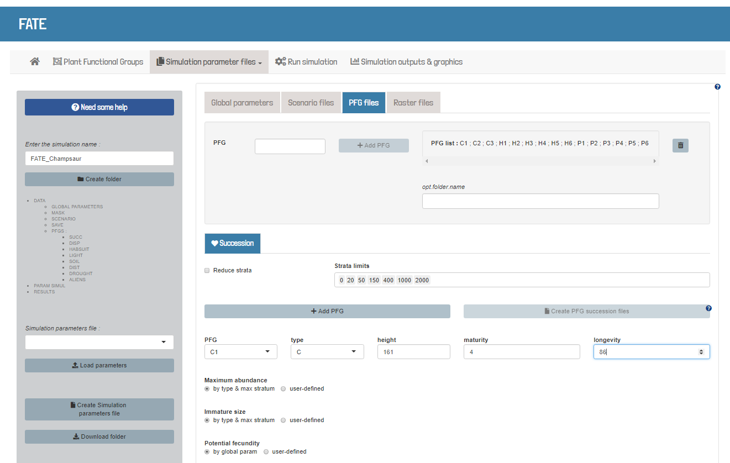

* 1. **Optional modules**
     1. **Dispersal**

« *The quantity of produced seeds depends on the abundances of mature PFGs and their habitat suitability. A seed dispersal model determines seed inflow in each pixel (Fig. 1c). From the source, three circles of influence are defined using distance parameters. In the first circle, 50% of the seeds are distributed uniformly. In the second circle, 49% of the seeds are distributed with the same concentration as in the first circle but by pairs of pixels, simulating the spatial autocorrelation of dispersed seeds. In the third circle, 1% of the seeds fall into a random pixel. This seed dispersal model behaves similar to a continuous kernel function (see Fig.S1a) but is very effective and requires only a few parameters (Vittoz & Engler, 2007).*» (Boulangeat, 2014)

Required parameters :

* In [GlobalParameters](https://leca-dev.github.io/RFate/reference/PRE_FATE.params_globalParameters.html) file :

DO_DISPERSAL 1

DISPERSAL_MODE 1

DISPERSAL_SAVING 0

* In [SimulParameters](https://leca-dev.github.io/RFate/reference/PRE_FATE.params_simulParameters.html) file :

--PFG_PARAMS_DISPERSAL--

FATE_simulation/DATA/PFGS/DISP/DISP_PFG1.txt

FATE_simulation/DATA/PFGS/DISP/DISP_PFG2.txt

* In [DISPERSAL](https://leca-dev.github.io/RFate/reference/PRE_FATE.params_PFGdispersal.html) files (given with the --PFG_PARAMS_DISPERSAL-- flag in *SimulParameters* file) :

NAME PFG1

DISPERS_DIST 100 500 79000

# ## Load example data

# Champsaur_PFG = .loadData("Champsaur_PFG", "RData")

#

# ## Build PFG traits for dispersal

# tab.traits = Champsaur_PFG$PFG.traits

# ## Dispersal values

# ## = Short: 0.1-2m; Medium: 40-100m; Long: 400-500m

# ## = Vittoz correspondance : 1-3: Short; 4-5: Medium; 6-7:Long

# corres = data.frame(dispersal = 1:7

# , d50 = c(0.1, 0.5, 2, 40, 100, 400, 500)

# , d99 = c(1, 5, 15, 150, 500, 1500, 5000)

# , ldd = c(1000, 1000, 1000, 5000, 5000, 10000, 10000))

# tab.traits$d50 = corres$d50[tab.traits$dispersal]

# tab.traits$d99 = corres$d99[tab.traits$dispersal]

# tab.traits$ldd = corres$ldd[tab.traits$dispersal]

# str(tab.traits)

## Load example data

Champsaur_params = .loadData("Champsaur_params", "RData")

## Create a skeleton folder

PRE_FATE.skeletonDirectory(name.simulation = 'FATE_Champsaur')

## PFG traits for dispersal

tab.disp = Champsaur_params$tab.DISP

str(tab.disp)

## Create PFG dispersal parameter files --------------------------------------

PRE_FATE.params_PFGdispersal(name.simulation = 'FATE_Champsaur'

, mat.PFG.disp = Champsaur_params$tab.DISP)

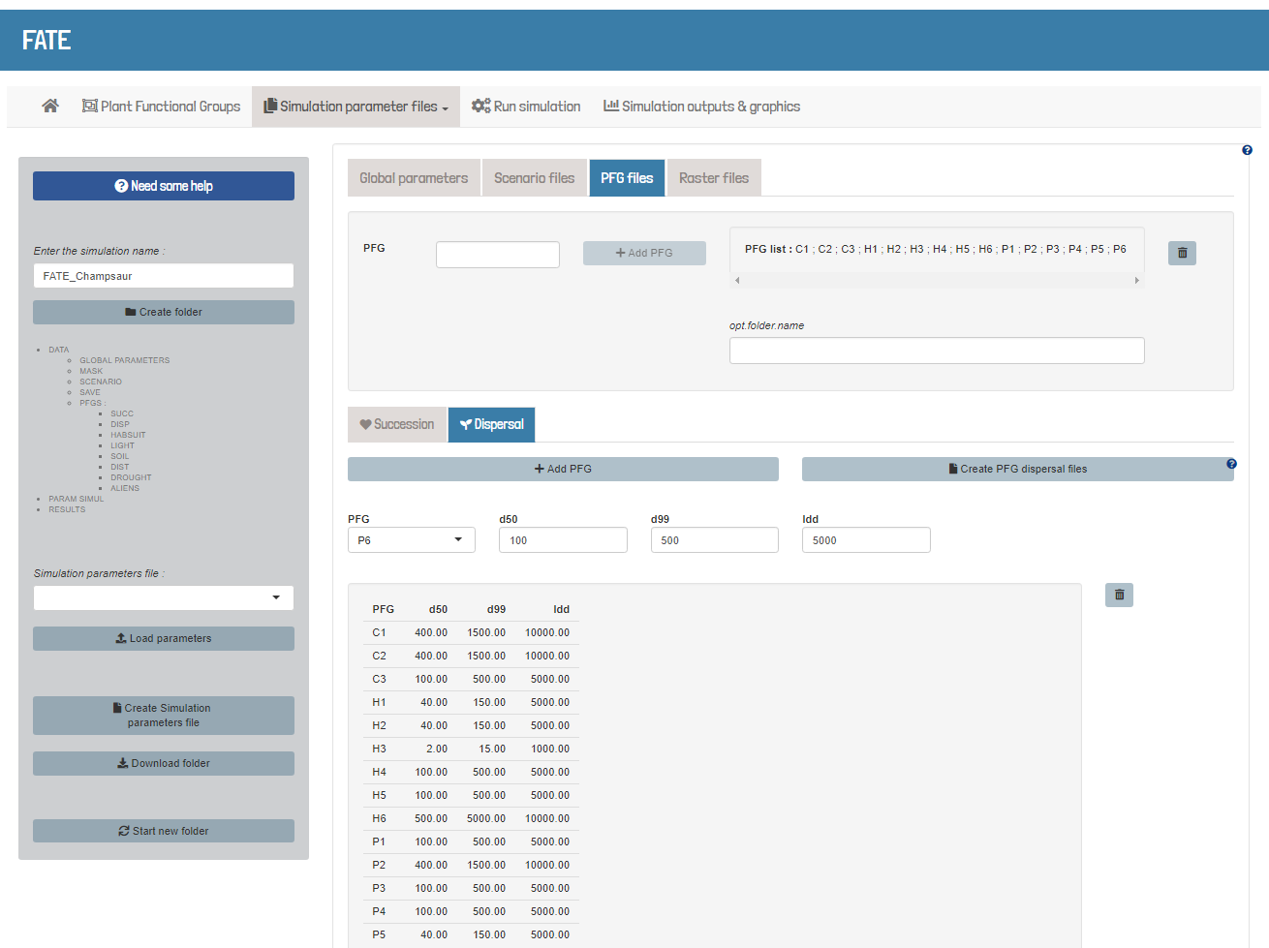

* + 1. **Habitat suitability**

« *Modelling how habitat suitability affects species population dynamics is tricky given the limited knowledge on the type and form of this relationship. Gallien et al. (2010) suggested a parsimonious approach using only presence-absences or a linear link. In FATE-HD, the probability for recruitment and seed production occurring is calculated every year according to the habitat suitability of the PFG in the pixel in question. Over time, the probability of presence is thus linearly related to fecundity and establishment. Accounting for interannual variability allows species coexistence via temporal niches. Mortality does not depend on habitat suitability, as the immediate effects of annual abiotic conditions on plant mortality are not clear in the literature. Habitat suitability for each PFG can be obtained from various sources such as correlative species distribution models (Guisan & Thuiller, 2005) or mechanistic niche models (Chuine & Beaubien, 2001).* » (Boulangeat, 2014)

Required parameters :

* In [GlobalParameters](https://leca-dev.github.io/RFate/reference/PRE_FATE.params_globalParameters.html) file :

DO_HAB_SUITABILITY 1

HABSUIT_MODE 1

* In [SimulParameters](https://leca-dev.github.io/RFate/reference/PRE_FATE.params_simulParameters.html) file :

--PFG_MASK_HABSUIT--

FATE_simulation/DATA/PFGS/HABSUIT/HS_CA/HS_PFG1_0.tif

FATE_simulation/DATA/PFGS/HABSUIT/HS_CA/HS_PFG2_0.tif

Habitat suitability maps can be changed through simulation time.

Two supplementary type of files are then needed :

1. a file with each row indicating each simulation year of change
2. as many files as the number of years indicated in the previous file, and inside them, as many lines as PFG, with a path for a new habitat suitability for each of them

--HABSUIT_CHANGEMASK_YEARS--

FATE_simulation/DATA/SCENARIO/HABSUIT/HABSUIT_changingmask_years.txt

--HABSUIT_CHANGEMASK_FILES--

FATE_simulation/DATA/SCENARIO/HABSUIT/HABSUIT_changingmask_files_t20.txt

FATE_simulation/DATA/SCENARIO/HABSUIT/HABSUIT_changingmask_files_t30.txt

FATE_simulation/DATA/SCENARIO/HABSUIT/HABSUIT_changingmask_files_t50.txt

FATE_simulation/DATA/SCENARIO/HABSUIT/HABSUIT_changingmask_files_t100.txt

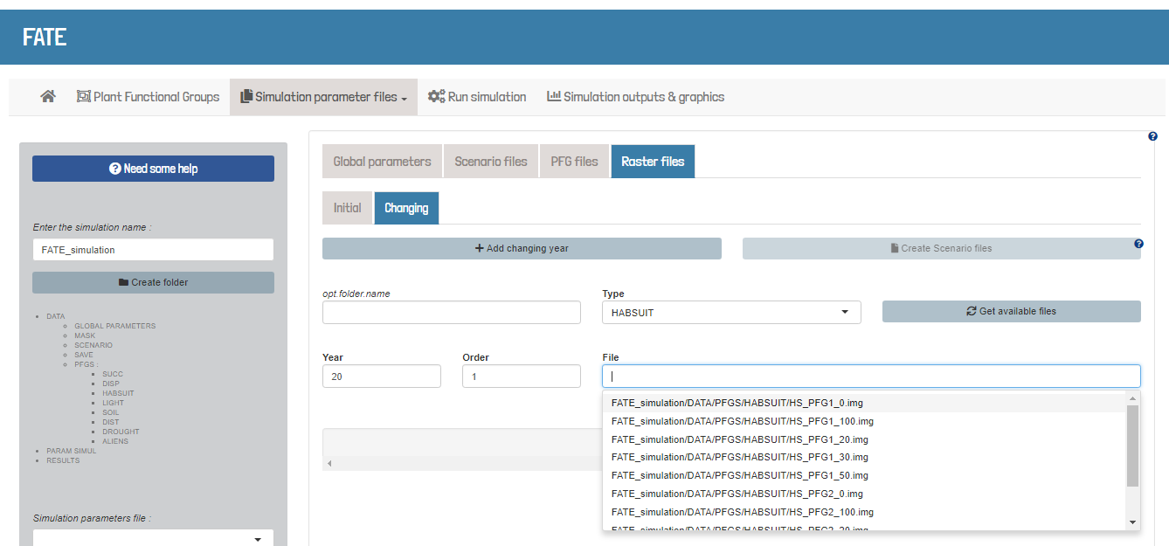

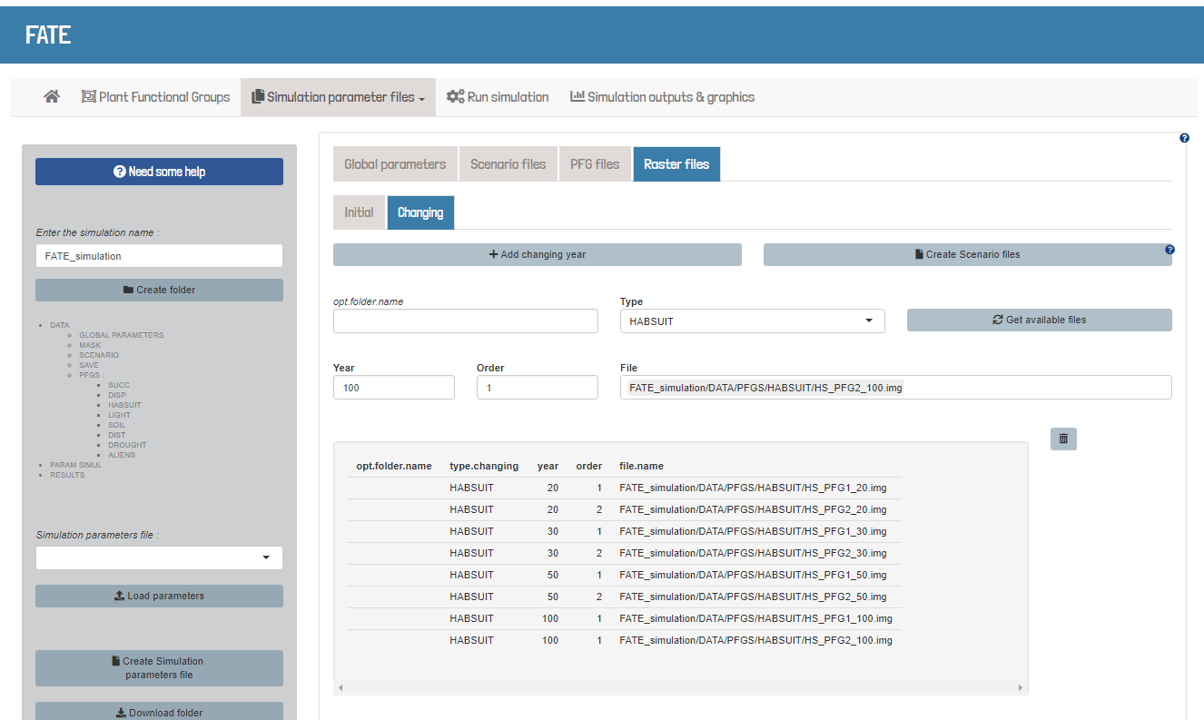

* + 1. **Light interaction**

« *Vegetation height is represented by a limited number of strata to incorporate the shading process (Fig. 1a). Within a pixel, the light resource for each stratum is calculated from the total abundance of all PFGs across all the upper strata. Within-pixel spatial heterogeneity in light resources is not taken into consideration* » (Boulangeat, 2014)

Required parameters :

* In [GlobalParameters](https://leca-dev.github.io/RFate/reference/PRE_FATE.params_globalParameters.html) file :

DO_LIGHT_INTERACTION 1

LIGHT_THRESH_MEDIUM 13000

LIGHT_THRESH_LOW 19000

LIGHT_SAVING 1

* In [SimulParameters](https://leca-dev.github.io/RFate/reference/PRE_FATE.params_simulParameters.html) file :

--PFG_PARAMS_LIGHT--

FATE_simulation/DATA/PFGS/LIGHT/LIGHT_PFG1.txt

FATE_simulation/DATA/PFGS/LIGHT/LIGHT_PFG2.txt

* In [LIGHT](https://leca-dev.github.io/RFate/reference/PRE_FATE.params_PFGlight.html) files (given with the --PFG_PARAMS_LIGHT-- flag in *SimulParameters* file) :

NAME PFG1

ACTIVE_GERM 9 9 9

LIGHT 4

LIGHT_TOL 1 1 1 1 1 1 1 1 1

## Load example data

Champsaur_params = .loadData("Champsaur_params", "RData")

## Create a skeleton folder

PRE_FATE.skeletonDirectory(name.simulation = 'FATE_Champsaur')

## PFG traits for light

tab.light = Champsaur_params$tab.LIGHT

str(tab.light)

## Create PFG light parameter files ------------------------------------------

PRE_FATE.params_PFGlight(name.simulation = 'FATE_Champsaur'

, mat.PFG.light = tab.light[, c("PFG", "type")]

, mat.PFG.tol = tab.light[, c("PFG", "strategy_tol")])

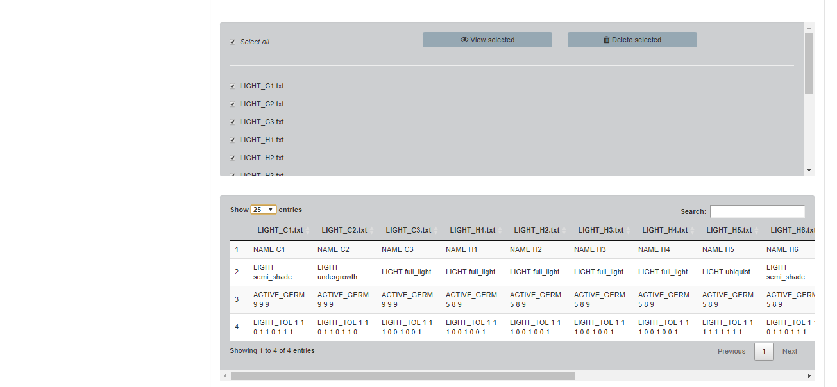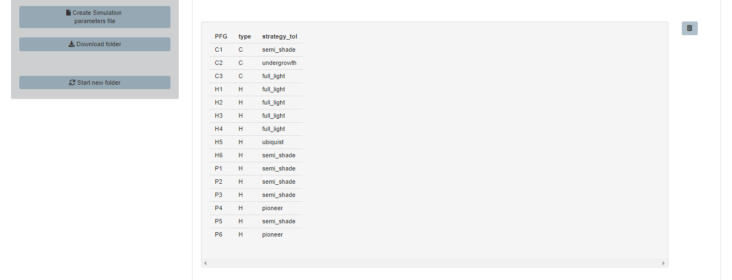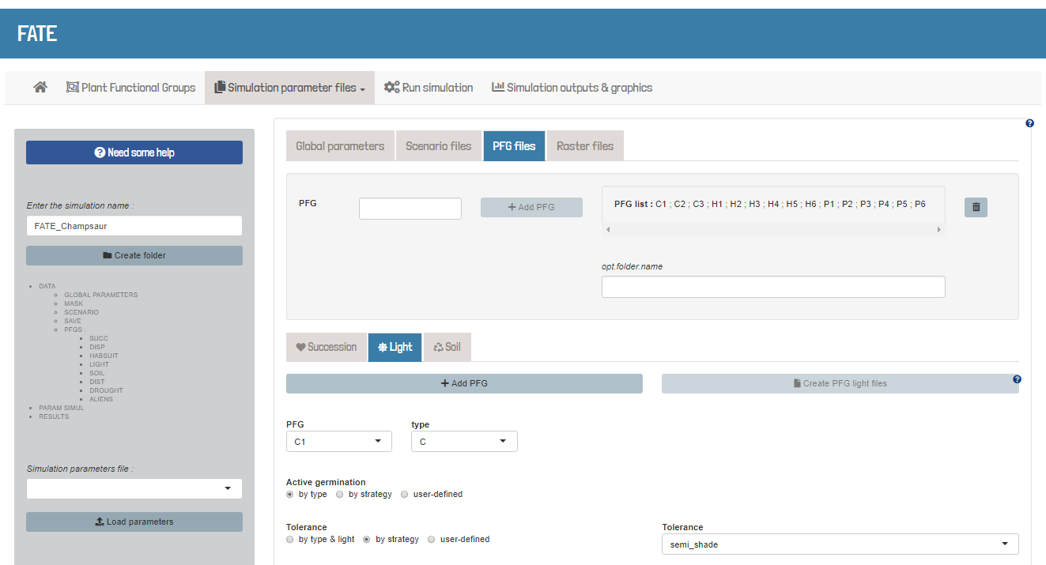

* + 1. **Soil interaction**

*“To be written” ()*

Required parameters :

* In [GlobalParameters](https://leca-dev.github.io/RFate/reference/PRE_FATE.params_globalParameters.html) file :

DO_SOIL_INTERACTION 1

SOIL_INIT 2.5

SOIL_RETENTION 0.8

SOIL_SAVING 1

* In [SimulParameters](https://leca-dev.github.io/RFate/reference/PRE_FATE.params_simulParameters.html) file :

--PFG_PARAMS_SOIL--

FATE_simulation/DATA/PFGS/SOIL/SOIL_PFG1.txt

FATE_simulation/DATA/PFGS/SOIL/SOIL_PFG2.txt

* In SOIL files (given with the --PFG_PARAMS_SOIL-- flag in *SimulParameters* file) :

NAME PFG1

ACTIVE_GERM 8 10 5

SOIL_CONTRIB 2.4

SOIL_LOW 1

SOIL_HIGH 4

SOIL_TOL 1 10 0 5 10 4 9 10 8

## Load example data

Champsaur_params = .loadData("Champsaur_params", "RData")

## Create a skeleton folder

PRE_FATE.skeletonDirectory(name.simulation = 'FATE_Champsaur')

## PFG traits for soil

tab.soil = Champsaur_params$tab.SOIL

str(tab.soil)

## Create PFG soil parameter files -------------------------------------------

PRE_FATE.params_PFGsoil(name.simulation = 'FATE_Champsaur'

, mat.PFG.soil = tab.soil)

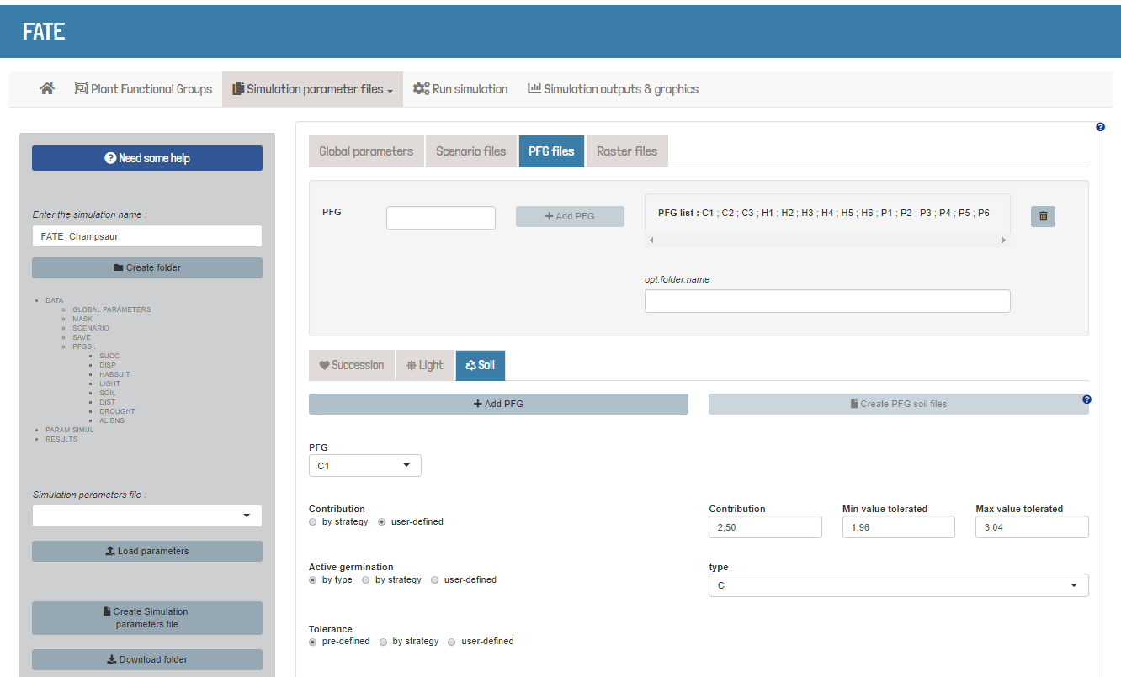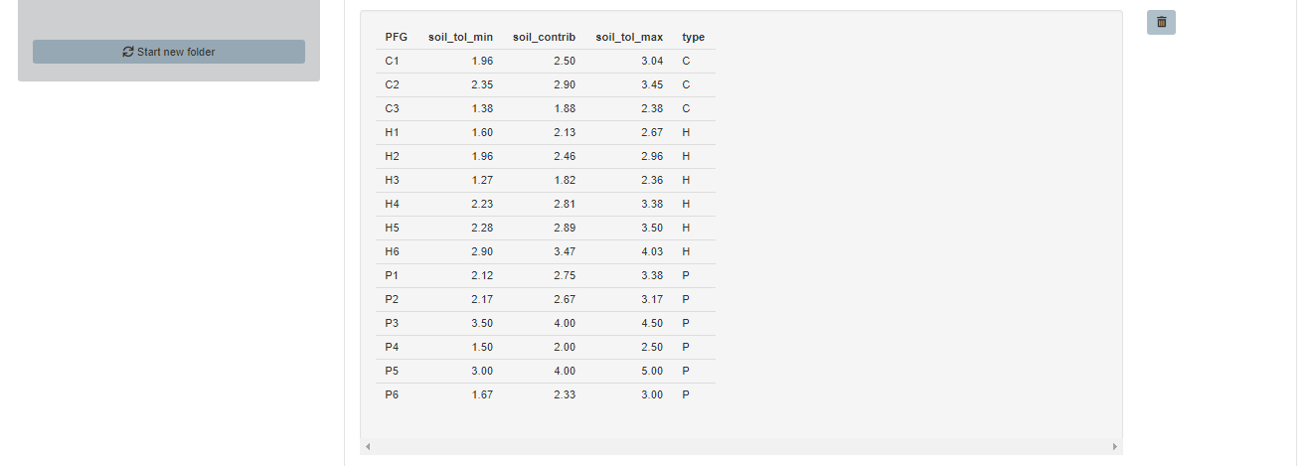

* + 1. **Disturbances**

« *Several disturbance models can be parameterized to remove vegetation, affect fecundity, kill seeds or activate dormant seeds according to each PFG’s tolerance or sensitivity to the given disturbance. (Fig. 1d).* » (Boulangeat, 2014)

Required parameters :

* In [GlobalParameters](https://leca-dev.github.io/RFate/reference/PRE_FATE.params_globalParameters.html) file :

DO_DISTURBANCES 1

DIST_NO 4

DIST_NOSUB 4

DIST_FREQ 1 1 1 1

* In [SimulParameters](https://leca-dev.github.io/RFate/reference/PRE_FATE.params_simulParameters.html) file :

--PFG_PARAMS_DISTURBANCES--

FATE_simulation/DATA/PFGS/DIST/DIST_PFG1.txt

FATE_simulation/DATA/PFGS/DIST/DIST_PFG2.txt

--DIST_MASK--

FATE_simulation/DATA/MASK/mask_noPerturb.tif

FATE_simulation/DATA/MASK/mask_mowing.tif

FATE_simulation/DATA/MASK/mask_grazing_level1.tif

FATE_simulation/DATA/MASK/mask_grazing_level2.tif

Like habitat suitability maps, disturbances maps can be changed through simulation time.

Two supplementary type of files are then needed :

1. a file with each row indicating each simulation year of change
2. as many files as the number of years indicated in the previous file, and inside them, as many lines as disturbances, with a path for a new mask for each of them

--DIST_CHANGEMASK_YEARS--

FATE_simulation/DATA/SCENARIO/DIST_scen1/DIST_changingmask_years.txt

--DIST_CHANGEMASK_FILES--

FATE_simulation/DATA/SCENARIO/DIST_scen1/DIST_changingmask_files_t50.txt

FATE_simulation/DATA/SCENARIO/DIST_scen1/DIST_changingmask_files_t100.txt

FATE_simulation/DATA/SCENARIO/DIST_scen1/DIST_changingmask_files_t150.txt

## Load example data

Champsaur_params = .loadData("Champsaur_params", "RData")

## Create a skeleton folder

PRE_FATE.skeletonDirectory(name.simulation = 'FATE_Champsaur')

## Changing_times table for disturbance

tab.changing = data.frame(year = c(600, 601, 800, 801)

, order = rep(1, 4)

, new.value = c("MASK_mowing.img"

, "MASK_noDisturb.img"

, "MASK_mowing.img"

, "MASK_noDisturb.img"))

## Create a Changing_times parameter file ------------------------------------

PRE_FATE.params_changingYears(name.simulation = 'FATE_Champsaur'

, type.changing = 'DIST'

, mat.changing = tab.changing)

* In DISTURBANCE files (given with the --PFG_PARAMS_DISTURBANCES-- flag in *SimulParameters* file) :

NAME PFG1

BREAK_AGE 2 4 10 2 4 10 2 4 10 2 4 10

RESPR_AGE 0 0 0 0 0 0 0 0 0 0 0 0 0 0 0 0

FATES 0 0 0 0 5 2 4 0 0 0 0 0 0 0 0 0 0 0 0 0 0 1 0 0 0 0 0 0 0 2 0 1

PROP_KILLED 0 0 0 0

ACTIVATED_SEED 0 0 0 0

## Load example data

Champsaur_params = .loadData("Champsaur_params", "RData")

## Create a skeleton folder

PRE_FATE.skeletonDirectory(name.simulation = 'FATE_Champsaur')

## PFG traits for succession

tab.succ = Champsaur_params$tab.SUCC

str(tab.succ)

## Create PFG succession parameter files (fixing strata limits) --------------

PRE_FATE.params_PFGsuccession(name.simulation = 'FATE_Champsaur'

, mat.PFG.succ = tab.succ

, strata.limits = c(0, 20, 50, 150, 400, 1000, 2000)

, strata.limits_reduce = FALSE)

tmp = fread("FATE_Champsaur/DATA/PFGS/SUCC_COMPLETE_TABLE.csv")

tab.succ = Champsaur_params$tab.SUCC

tab.succ$age_above_150cm = tmp$CHANG_STR_AGES_to_str_4_150

## PFG traits for disturbance

tab.dist = Champsaur_params$tab.DIST

str(tab.dist)

## Create PFG response to disturbance parameter files (give warnings) --------

PRE_FATE.params_PFGdisturbance(name.simulation = 'FATE_Champsaur'

, mat.PFG.dist = tab.succ

, mat.PFG.tol = tab.dist)

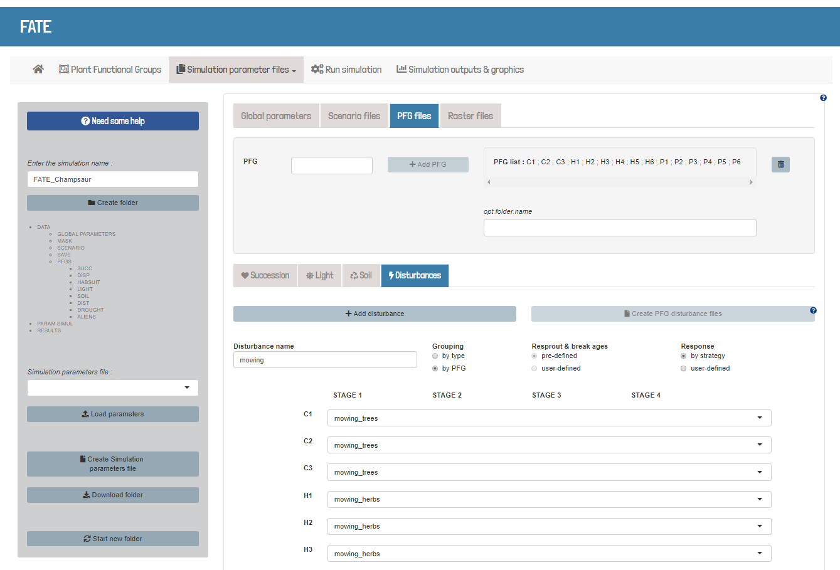

* + 1. **Drought**

« *Fig. 1. Drought simulation scheme. For each year i, a PFG’s habitat suitability (HS; step 1) and drought effects (step 2) are evaluated within a pixel j. If HS ij or Din ij are below reference values, PFG fecundity and recruitment are set to 0. Additionally, if Din ij crosses the reference value, one drought year is added to the PFG’s cumulative drought effects counter. Severe drought effects occur if conditions 2.3.1 ii or 2.3.2 are met, consisting in immediate and post-drought effects. Otherwise, only moderate drought effects are caused (2.1 and 2.3.1 i). Drought recovery is simulated by subtracting one or two drought events from the cumulative drought effects counter. […] See Table S3 in Appendix S2 for full parameter list and refer to main text for further details.*» (Barros, 2017)

Required parameters :

* In [GlobalParameters](https://leca-dev.github.io/RFate/reference/PRE_FATE.params_globalParameters.html) file :

DO_DROUGHT_DISTURBANCE 1

DROUGHT_NOSUB 4

* In [SimulParameters](https://leca-dev.github.io/RFate/reference/PRE_FATE.params_simulParameters.html) file :

--PFG_PARAMS_DROUGHT--

FATE_simulation/DATA/PFGS/DROUGHT/DROUGHT_PFG1.txt

FATE_simulation/DATA/PFGS/DROUGHT/DROUGHT_PFG2.txt

--DROUGHT_MASK--

FATE_simulation/DATA/MASK/DROUGHT_init.tif

Like habitat suitability or disturbances maps, the drought index map can be changed through simulation time.

Two supplementary type of files are then needed :

1. a file with each row indicating each simulation year of change
2. as many files as the number of years indicated in the previous file,

and inside them, one line with a path for a new map of drought index

--DROUGHT_CHANGEMASK_YEARS--

FATE_simulation/DATA/SCENARIO/DROUGHT_changingmask_years.txt

--DROUGHT_CHANGEMASK_FILES--

FATE_simulation/DATA/SCENARIO/DROUGHT_changingmask_files_t15.txt

FATE_simulation/DATA/SCENARIO/DROUGHT_changingmask_files_t30.txt

FATE_simulation/DATA/SCENARIO/DROUGHT_changingmask_files_t45.txt

* In DROUGHT files (given with the --PFG_PARAMS_DROUGHT-- flag in *SimulParameters* file) :

NAME PFG1

BREAK_AGE 1 5 26 1 5 26

RESPR_AGE 0 0 3 26 0 0 3 26

FATES 6 0 2 0 5 0 6 0 2 0 5 0 1 0 2 0

PROP_KILLED 0 0

ACTIVATED_SEED 0 0

THRESHOLD_MOD -11.50406848

THRESHOLD_SEV -12.3335733

COUNTER_RECOVERY 1

COUNTER_SENS 3

COUNTER_CUM 3

* + 1. **Aliens**

« *We then simulated the introduction of the alien PFGs through annual seeding. The sites of simulated introduction were based on a map of the Human Footprint […] an index combining information on land-use, population density and transportation network (including mountain footpaths). As such it represents an excellent proxy of potential local propagule pressure for introduced species […] In the current propagule pressure scenario, introductions were a proportion of a set maximum number of seeds depending on the human footprint value in each pixel (i.e. highest introduction intensity in the most densely populated centres, and lowest introduction intensity along mountain footpaths; see Appendix S2 for maps and for details). In the increased propagule pressure scenario, the maximum introduction level was applied in all areas that had a non-zero human footprint (simulating a maximum exploitation of all areas suitable to humans).* » (Carboni, 2017)

Required parameters :

* In [GlobalParameters](https://leca-dev.github.io/RFate/reference/PRE_FATE.params_globalParameters.html) file :

DO_ALIENS_INTRODUCTION 1

ALIENS_NO 4

ALIENS_FREQ 2 2 2 2

* In [SimulParameters](https://leca-dev.github.io/RFate/reference/PRE_FATE.params_simulParameters.html) file :

--PFG_MASK_ALIENS--

FATE_simulation/DATA/PFGS/ALIENS/NoIntroduction.tif

FATE_simulation/DATA/PFGS/ALIENS/Introduction_ALIEN2.tif

FATE_simulation/DATA/PFGS/ALIENS/Introduction_ALIEN3.tif

FATE_simulation/DATA/PFGS/ALIENS/Introduction_ALIEN4.tif

Like habitat suitability or disturbances maps, aliens introduction masks can be changed through simulation time.

Two supplementary type of files are then needed :

1. a file with each row indicating each simulation year of change
2. as many files as the number of years indicated in the previous file,

and inside them, as many lines as PFG, with a path for a new mask for each of them

--ALIENS_CHANGEMASK_YEARS--

FATE_simulation/DATA/SCENARIO/ALIENS_changingmask_years.txt

--ALIENS_CHANGEMASK_FILES--

FATE_simulation/DATA/SCENARIO/ALIENS_changingmask_files_t20.txt

FATE_simulation/DATA/SCENARIO/ALIENS_changingmask_files_t25.txt

Once introduction maps have been set, frequency of introduction can also be changed through simulation time.

Two supplementary type of files are then needed :

1. a file with each row indicating each simulation year of change
2. as many files as the number of years indicated in the previous file,

and inside them, as many lines as PFG, with a number for each of them representing its introduction frequency

--ALIENS_CHANGEFREQ_YEARS--

FATE_simulation/DATA/SCENARIO/ALIENS_changingfreq_years.txt

--ALIENS_CHANGEFREQ_FILES--

FATE_simulation/DATA/SCENARIO/ALIENS_changingfreq_files_t20.txt

FATE_simulation/DATA/SCENARIO/ALIENS_changingfreq_files_t25.txt

* In SUCCESSION files (given with the --PFG_PARAMS_LIFE_HISTORY-- flag in *SimulParameters* file) :

IS_ALIEN 1

* + 1. **Fire**

*“To be written” ()*

Required parameters :

* In [GlobalParameters](https://leca-dev.github.io/RFate/reference/PRE_FATE.params_globalParameters.html) file :

DO_FIRE_DISTURBANCE 1

FIRE_NO 1

FIRE_NOSUB 4

FIRE_FREQ 2

FIRE_IGNIT_MODE 1

FIRE_NEIGH_MODE 2

FIRE_PROP_MODE 4

FIRE_QUOTA_MODE 2

Depending on the values given for the FIRE_IGNIT_MODE, FIRE_NEIGH_MODE, FIRE_PROP_MODE and FIRE_QUOTA_MODE parameters, more information might be needed :

FIRE_IGNIT_NO 12

FIRE_IGNIT_NOHIST 5 8 12 5 9 0 3 11 5 7 4

FIRE_IGNIT_LOGIS 0.6 2.5 0.05

FIRE_IGNIT_FLAMMMAX 10

FIRE_NEIGH_CC 4 3 4 3

FIRE_PROP_INTENSITY 0.5

FIRE_PROP_LOGIS 0.6 2.5 0.05

FIRE_QUOTA_MAX 1000

* In [SimulParameters](https://leca-dev.github.io/RFate/reference/PRE_FATE.params_simulParameters.html) file :

--PFG_PARAMS_FIRE--

FATE_simulation/DATA/PFGS/FIRE/FIRE_PFG1.txt

FATE_simulation/DATA/PFGS/FIRE/FIRE_PFG2.txt

--FIRE_MASK--

FATE_simulation/DATA/MASK/FIRE_init.tif

Like habitat suitability or disturbances maps, fire masks can be changed through simulation time.

Two supplementary type of files are then needed :

1. a file with each row indicating each simulation year of change
2. as many files as the number of years indicated in the previous file,

and inside them, as many lines as fire disturbances, with a path for a new mask for each of them

--FIRE_CHANGEMASK_YEARS--

FATE_simulation/DATA/SCENARIO/FIRE_changingmask_years.txt

--FIRE_CHANGEMASK_FILES--

FATE_simulation/DATA/SCENARIO/FIRE_changingmask_files_t20.txt

FATE_simulation/DATA/SCENARIO/FIRE_changingmask_files_t25.txt

Once introduction maps have been set, frequency of fires can also be changed through simulation time.

Two supplementary type of files are then needed :

1. a file with each row indicating each simulation year of change
2. as many files as the number of years indicated in the previous file,

and inside them, as many lines as fire disturbances, with a number for each of them representing its occuring frequency

--FIRE_CHANGEFREQ_YEARS--

FATE_simulation/DATA/SCENARIO/FIRE_changingfreq_years.txt

--FIRE_CHANGEFREQ_FILES--

FATE_simulation/DATA/SCENARIO/FIRE_changingfreq_files_t20.txt

FATE_simulation/DATA/SCENARIO/FIRE_changingfreq_files_t25.txt

Depending on the value given for the FIRE_PROP_MODE parameter, more information might be needed :

--ELEVATION_MASK--

FATE_simulation/DATA/MASK/elevation.tif

--SLOPE_MASK--

FATE_simulation/DATA/MASK/slope.tif

* In SUCCESSION files (given with the --PFG_PARAMS_LIFE_HISTORY-- flag in *SimulParameters* file) :

FLAMMABILITY 6

* In FIRE files (given with the --PFG_PARAMS_FIRE-- flag in *SimulParameters* file) :

NAME PFG1

BREAK_AGE 1 4 20

RESPR_AGE 0 1 3 12

FATES 8 0 6 4 5 5 4 6

PROP_KILLED 0 0

ACTIVATED_SEED 0 0

1. **Run a FATE simulation**

When all data and parameter files have been produced and correctly referred in a [SimulParameters](https://leca-dev.github.io/RFate/reference/PRE_FATE.params_simulParameters.html) file, a FATE simulation can be run using the [FATE](https://leca-dev.github.io/RFate/reference/FATE.html) function :

* the simulation will start, and the software will **print messages into the console** indicating what the software is doing.
* depending on the simulation duration, the size and the resolution of the study area, the number of Plant Functional Groups (PFG) involved, … running the full simulation **could take a while**.

**Note :** the folder from which the command is sent must be adapted based on how paths to files have been given within the [SimulParameters](https://leca-dev.github.io/RFate/reference/PRE_FATE.params_simulParameters.html) file :

* If all paths are **absolute**

(i.e. including the root, such as */home/username/FATE_simulation/DATA/ GLOBAL_PARAMETERS/Global_parameters_V1.txt*),

there should not be any problem. The only requirement then is to also give absolute path to the simulation folder, if not in the current directory.

* If all paths are **relative**

(i.e. starting from a specific folder, such as *FATE_simulation/DATA/GLOBAL_PARAMETERS/Global_parameters_V1.txt*),

then the FATE simulation must be run from this specific folder (i.e. here from the folder containing the FATE_simulation folder).

1. **Outputs & analyses**
   1. **FATE outputs**

Once the simulation is completed, the directory defined under the flag --SAVING_DIR-- within the [SimulParameters](https://leca-dev.github.io/RFate/reference/PRE_FATE.params_simulParameters.html) file must contain the following directories (depending on the parameters selected and the modules activated within the [GlobalParameters](https://leca-dev.github.io/RFate/reference/PRE_FATE.params_globalParameters.html) file) :

* *ABUND_allPFG_perStrata/*
* *ABUND_perPFG_allStrata/*
* *ABUND_perPFG_perStrata/*

Each of them contains raster files with the abundance of Plant Functional Groups (PFG) (which should be considered as a proxy for the vegetation coverage/abundance) contained within each pixel of the study area. The files within each folder show different informations :

* *ABUND_perPFG_perStrata/* :

**one specific year**, and the abundance of **a specific PFG** in **a specific stratum**

* *ABUND_allPFG_perStrata/* :

**one specific year**, and the abundance of **all PFGs** in **a specific stratum**

* *ABUND_perPFG_allStrata/* :

**one specific year**, and the abundance of **a specific PFG** within **all strata**

If the corresponding modules were activated within the [GlobalParameters](https://leca-dev.github.io/RFate/reference/PRE_FATE.params_globalParameters.html) file, the following folders may also exist and contain output files :

* *DISPERSAL/*
* *LIGHT/*
* *SOIL/*

These ouputs can then be used as is, or post-treated with functions from the RFate package to obtain more specific results (e.g. evolution of abundance curves, cover or diversity maps, etc).

* 1. **Temporal evolution**

Results are saved as raster files, and archived to save some place. Extracting and retrieving informations for each PFG, pixel or height stratum can take some time. The [POST_FATE. temporalEvolution](https://leca-dev.github.io/RFate/reference/POST_FATE.temporalEvolution.html) function takes care of the **extraction** (which can be parallelized) and concatenates the values in one table file.

## Load example data

.loadData("Champsaur_results", "7z")

## Select a parameter file

# param = "Simul_parameters_V1.1.txt"

param = "Simul_parameters_V2.1.txt"

# param = "Simul_parameters_V3.1.txt"

# param = "Simul_parameters_V4.1.txt"

simul.name = "FATE_Champsaur"

simul.param = paste0("FATE_Champsaur/PARAM_SIMUL/", param)

## TEMPORAL EVOLUTION -------------------------------------------------------

POST_FATE.temporalEvolution(name.simulation = simul.name

, file.simulParam = simul.param

, no_years = 30)

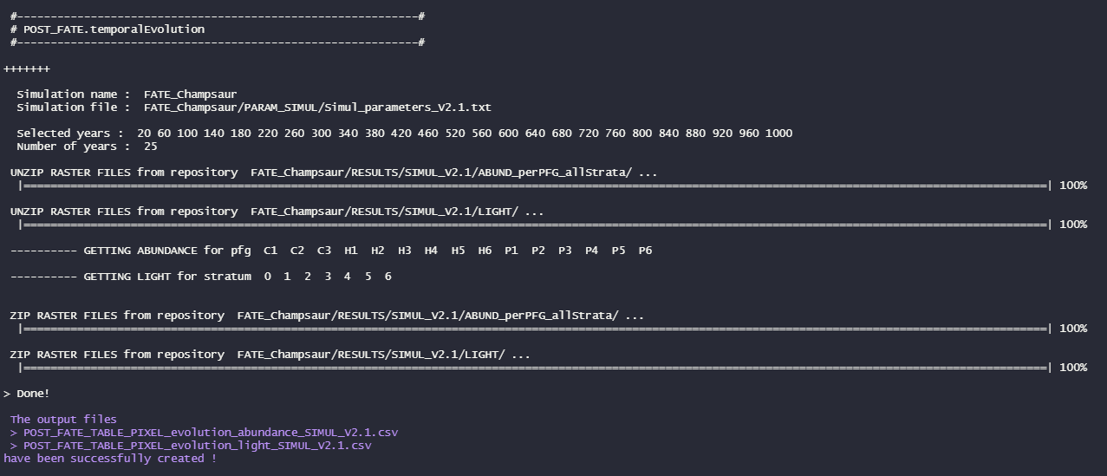

Once this table is obtained, three other functions are available to **represent the evolution of these results through the simulation time** :

* The [POST_FATE.graphic_evolutionCoverage](https://leca-dev.github.io/RFate/reference/POST_FATE.graphic_evolutionCoverage.html) function draws, for each PFG, its space occupation and its total abundance over the whole simulation area.

POST_FATE.graphic_evolutionCoverage(name.simulation = simul.name

, file.simulParam = simul.param)

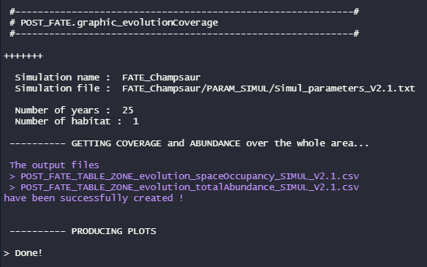

* The [POST_FATE.graphic_evolutionPixels](https://leca-dev.github.io/RFate/reference/POST_FATE.graphic_evolutionPixels.html) function focuses on some pixels (either given or randomly drawn). The abundance of PFG through time within these pixels is represented, together with the pixel resources (light, soil) if the corresponding modules were activated within the [GlobalParameters](https://leca-dev.github.io/RFate/reference/PRE_FATE.params_globalParameters.html) file.

POST_FATE.graphic_evolutionPixels(name.simulation = simul.name

, file.simulParam = simul.param)

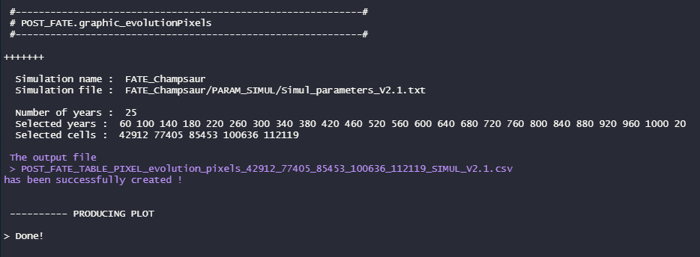

* The [POST_FATE.graphic_evolutionStability](https://leca-dev.github.io/RFate/reference/POST_FATE.graphic_evolutionStability.html) function is a bit more specific, and was built to study the habitat composition stability over the whole simulation area.

POST_FATE.graphic_evolutionStability(name.simulation = simul.name

, file.simulParam = simul.param)

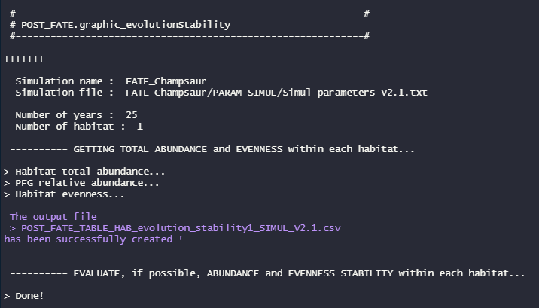

* 1. **From abundance to presence/absence**

As FATE abundances are quite arbitrary (no direct link in terms of number of individuals), results are more easily interpreted when transformed as **relative abundances** or **presence/absence** values. Several methods are available to perform this final transformation at the user’s convenience.

* The [POST_FATE.relativeAbund](https://leca-dev.github.io/RFate/reference/POST_FATE.relativeAbund.html) function creates, for the required years, raster maps of PFG relative abundances into the *ABUND_perPFG_allStrata/* folder.

## RELATIVE ABUNDANCE / BINARY MAPS & VALIDATION -----------------------------

POST_FATE.relativeAbund(name.simulation = simul.name

, file.simulParam = simul.param

, years = 1000)

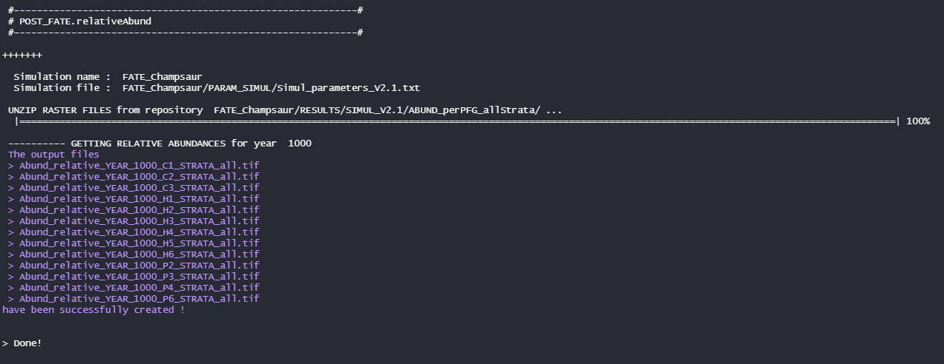

* The [POST_FATE.graphic_validationStatistics](https://leca-dev.github.io/RFate/reference/POST_FATE.graphic_validationStatistics.html) function can then be used, to calculate and represent TSS and AUC values for each PFG. The threshold to convert relative abundances into presence/absence values is automatically chosen to maximize the TSS values.

Champsaur_params = .loadData("Champsaur_params", "RData")

## PFG observations

tab.occ = Champsaur_params$tab.occ

tab.xy = Champsaur_params$tab.xy

## Merge observations and sites coordinates

tab.obs = merge(tab.occ, tab.xy, by = "row.names")

tab.obs = melt(tab.obs, id.vars = c("Row.names", "X", "Y"))

colnames(tab.obs) = c("sites", "X", "Y", "PFG", "obs")

tab.obs = na.exclude(tab.obs)

head(tab.obs)

tab = tab.obs[, c("PFG", "X", "Y", "obs")]

POST_FATE.graphic_validationStatistics(name.simulation = simul.name

, file.simulParam = simul.param

, years = 1000

, mat.PFG.obs = tab)

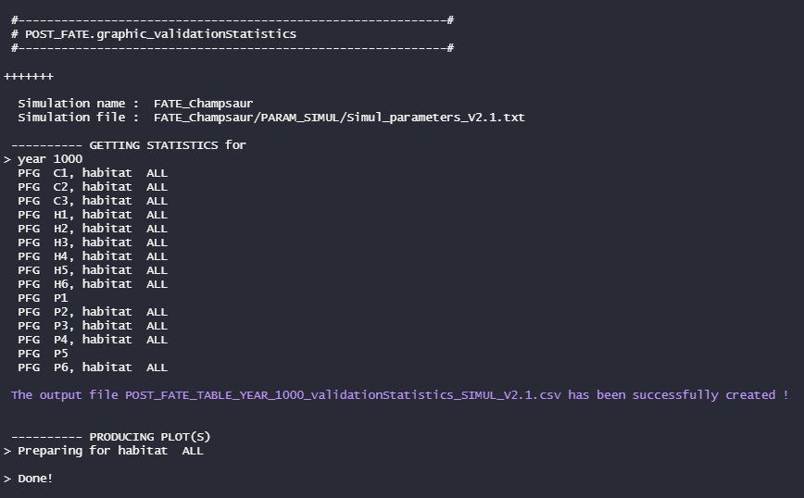

* The [POST_FATE.binaryMaps](https://leca-dev.github.io/RFate/reference/POST_FATE.binaryMaps.html) function creates, for the required years, raster maps of PFG presence/absence into the *BIN_perPFG_allStrata/* folder and *BIN_perPFG_ perStrata/* folders. Two methods are available to perform such transformation :
  1. By setting manually a conversion threshold for the relative abundance maps (*e.g. : all PFG representing more than 10% of a pixel total abundance are considered as present within this pixel*)

POST_FATE.binaryMaps(name.simulation = simul.name

, file.simulParam = simul.param

, years = 1000

, method = 1

, method1.threshold = 0.05)

* 1. By using specific cutoffs for each PFG, that can be obtained from the [POST_FATE.graphic_validationStatistics](https://leca-dev.github.io/RFate/reference/POST_FATE.graphic_validationStatistics.html) function for example.
* The [POST_FATE.graphic_mapPFGvsHS](https://leca-dev.github.io/RFate/reference/POST_FATE.graphic_mapPFGvsHS.html) function represents together, for each PFG, its habitat suitability map (if the module was activated within the [GlobalParameters](https://leca-dev.github.io/RFate/reference/PRE_FATE.params_globalParameters.html) file) and its presence/absence map obtained from the FATE simulation.

POST_FATE.graphic_mapPFGvsHS(name.simulation = simul.name

, file.simulParam = simul.param

, years = 1000)

* 1. **Visualization of outputs**

Finally, some simple representations can be obtained with the [POST_FATE.graphic_mapPFG](https://leca-dev.github.io/RFate/reference/POST_FATE.graphic_mapPFG.html) function, for the required years :

* The PFG richness : the sum of all PFG present in each pixel ;
* The PFG relative cover : the total abundance of all PFG within each pixel, divided by the maximum total abundance found in a pixel over the whole simulation area ;
* The resources community weighted mean (light and soil, if the corresponding modules were activated within the [GlobalParameters](https://leca-dev.github.io/RFate/reference/PRE_FATE.params_globalParameters.html) file).

Specific height strata (minimum and maximum to be considered) can be selected to perform these graphics, to be able to focus on specific vegetation layer.

**Publications**

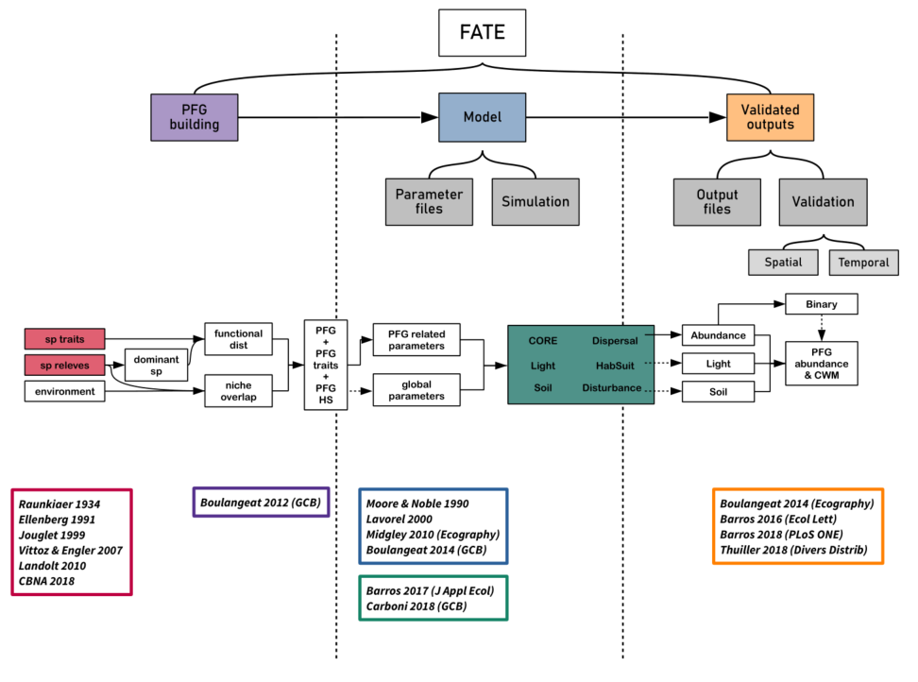

Figure 13: FATE publications workflow

**Origins (FATE / LAMOS / BioMove)**

* Moore A. D. and Noble I. R. (1990), An individualistic model of vegetation stand dynamics. https://doi.org/10.1016/s0301-4797(05)80015-5
* Lavorel S., Davies I. D. and Noble I. R. (2000). LAMOS: a landscape modelling shell. Landscape Fire Modeling-Challenges and Opportunities. Natural Resources Canada, Canadian Forest Service, Vancouver, BC, Canada, 25-28.
* Midgley G. F., Davies I. D., Albert C. H., Altwegg R., Hannah L., Hughes G. O., O’Halloran L. R., Seo C., Thorne J. H. and Thuiller W. (2010), BioMove – an integrated platform simulating the dynamic response of species to environmental change. Ecography, 33: 612-616. https://doi.org/10.1111/j.1600-0587.2009.06000.x

**FATE model**

* Boulangeat I., Philippe P., Abdulhak S., Douzet R., Garraud L., Lavergne S., Lavorel S., Van Es J., Vittoz P. and Thuiller W. (2012), Improving plant functional groups for dynamic models of biodiversity: at the crossroads between functional and community ecology. Glob Change Biol, 18: 3464-3475. https://doi.org/10.1111/j.1365-2486.2012.02783.x
* Boulangeat I., Georges D. and Thuiller W. (2014), FATE‐HD: a spatially and temporally explicit integrated model for predicting vegetation structure and diversity at regional scale. Glob Change Biol, 20: 2368-2378. https://doi.org/10.1111/gcb.12466

**Applications**

* Boulangeat I., Georges D., Dentant C., Bonet R., Van Es J., Abdulhak S., Zimmermann N. E. and Thuiller W. (2014), Anticipating the spatio‐temporal response of plant diversity and vegetation structure to climate and land use change in a protected area. Ecography, 37: 1230-1239. https://doi.org/10.1111/ecog.00694
* Barros C., Thuiller W., Georges D., Boulangeat I., Münkemüller T. and Bellwood D. (2016), N‐dimensional hypervolumes to study stability of complex ecosystems. Ecol Lett, 19: 729-742. https://doi.org/10.1111/ele.12617
* Barros C., Guéguen M., Douzet R., Carboni M., Boulangeat I., Zimmermann N. E., Münkemüller T., Thuiller W. and Mori A. (2017), Extreme climate events counteract the effects of climate and land‐use changes in Alpine tree lines. J Appl Ecol, 54: 39-50. https://doi.org/10.1111/1365-2664.12742
* Barros C., Thuiller W. and Münkemüller T. (2018), Drought effects on the stability of forest-grassland ecotones under gradual climate change. PLoS ONE 13(10): e0206138. https://doi.org/10.1371/journal.pone.0206138
* Carboni M., Guéguen M., Barros C., Georges D., Boulangeat I., Douzet R., Klonner G., Van Kleunen M., Essl F., Bossdorf O., Haeuser E., Talluto M. V., Moser D., Block S., Conti L., Dullinger I., Münkemüller T. and Thuiller W. (2018). Simulating plant invasion dynamics in mountain ecosystems under global change scenarios. Glob Change Biol, 24:e289–e302. https://doi.org/10.1111/gcb.13879
* Thuiller W, Guéguen M, Bison M, et al (2018). Combining point‐process and landscape vegetation models to predict large herbivore distributions in space and time—A case study of Rupicapra rupicapra. Divers Distrib, 24:352–362. https://doi.org/10.1111/ ddi.12684

**Supplementary material**

**COMPLETE EXAMPLE : Champsaur**